A Laboratory Manual for

Web Programming (3160713)

B.E. Semester 6 (Computer Engineering)




Directorate of Technical Education, Gandhinagar, Gujarat

Government Engineering College Palanpur Department of Computer Engineering


CERTIFICATE

This is to certify that Mr./Ms. Raval Atish Nirajnajkumar Enrollment No. 240613107023 of B.E. Semester 6, Computer Engineering of this Institute (GTU Code: 061)has satisfactorily completed the Practical / Tutorial work for the subject Web Programming (3160713) for the academic year 2025-2026.

Place: PALANPUR

Date:

Sign of Course Faculty Head of the Department

Preface

Main motto of any laboratory/practical/field work is for enhancing required skills as well as creating ability amongst students to solve real time problem by developing relevant competencies in psychomotor domain. By keeping in view, GTU has designed competency focused outcome-based curriculum for engineering degree programs where sufficient weightage is given to practical work. It shows importance of enhancement of skills amongst the students and it pays attention to utilize every second of time allotted for practical amongst students, instructors and faculty members to achieve relevant outcomes by performing the experiments rather than having merely study type experiments. It is must for effective implementation of competency focused outcome-based curriculum that every practical is keenly designed to serve as a tool to develop and enhance relevant competency required by the various industry among every student. These psychomotor skills are very difficult to develop through traditional chalk and board content delivery method in the classroom. Accordingly, this lab manual is designed to focus on the industry defined relevant outcomes, rather than old practice of conducting practical to prove concept and theory.
By using this lab manual students can go through the relevant theory and procedure in advance before the actual performance which creates an interest and students can have basic idea prior to performance. This in turn enhances pre-determined outcomes amongst students. Each experiment in this manual begins with competency, industry relevant skills, course outcomes as well as practical outcomes (objectives). The students will also achieve safety and necessary precautions to be taken while performing practical.
This manual also provides guidelines to faculty members to facilitate student centric lab activities through each experiment by arranging and managing necessary resources in order that the students follow the procedures with required safety and necessary precautions to achieve the outcomes. It also gives an idea that how students will be assessed by providing rubrics.
In the era of digitization, the demand of Internet based applications is increasing day by day. Web Development is one of the required skills for IT Engineer. This focuses on front-end and back-end design. After learning Web Development students can advance their career in the field of web development.
Utmost care has been taken while preparing this lab manual however always there is chances of improvement. Therefore, we welcome constructive suggestions for improvement and removal of errors if any.

Practical – Course Outcome matrix

Course Outcomes (COs):
CO-1: Use the various HTML tags with appropriate styles to display the various types of contents effectively.
CO-2: Develop the dynamic web pages using HTML, CSS and JavaScript applying web design principles to make pages effective.
CO-3: Develop the server side PHP scripts using various features for creating customized web services.
CO-4: Write the server side scripts for designing web based services with database connectivity.
CO-5: Develop a web application using advanced web programming features including
AJAX and JQuery using concepts of Web API.
Sr.  No. | Objective(s) of Experiment | CO  1 | CO  2 | CO  3 | CO  4 | CO  5
1. | Create your resume using HTML (Suggested sections of resume are Personal Information, Educational Information, Professional Skills, Experience, Achievements, Hobbies), Experiment with text, colors,  link and lists. | √
2. | Create your class time table using table tag, experiment  with rowspan, colspan, cellspacing and cellpadding attributes. | √
3. | Design static web pages for your college containing a  description of the courses, departments, faculties, library etc. Provide links for navigation among pages. | √
4. | Create User Registration Form in HTML (Suggested to use fields like Name, Date of Birth, Gender, Email Id, Mobile No.,Address, State , Education , Image Upload etc) using textbox, textarea, checkbox, radio button,  select box, button, file upload etc. | √
5. | Create two web pages, one contains audios and other page contains videos (using HTML5 audio and video  tags). Also provide link for navigation between pages. | √
6. | Create a web page using frame. Divide the page into two parts with Navigation links on left hand side of page (width=20%) and content page on right hand side of page (width = 80%). On clicking the navigation Links corresponding content must be shown on the  right-hand side. | √
7. | Design a web page of your home town with an  attractive background color, text color, an Image, font etc. (use internal CSS). | √
8. | Use Inline CSS to format your resume that you created  in practical no 01. | √

9. | Use External, Internal, Inline CSS to format College  Web site that you created in Practical No.03 | √
10. | Develop a java script to display today’s date. |  | √
11. | Develop simple calculator for addition, subtraction,  multiplication and division operation using java script. |  | √
12. | Write a java script code to combine and display the  information in textbox when the button is clicked use registration page that you created in Practical No.4. |  | √
13. | Use JavaScript to Implement validation in Practical No.4. |  | √
14. | Write a PHP program to check if number is prime or  not. |  |  | √
15. | Use Registration Form from practical number 4 to store user registration details in MySql database. On submission next page displays all registration data in in html table using php. Also provide feature to update and  delete the registration data. |  |  |  | √
16. | Write a PHP script for user authentication using PHP-  MYSQL. Use session for storing username. |  |  |  | √
17. | Using AJAX Create visual search feature to search  using name for practical number 15 which list name, mobile number and email id of matching users. |  |  |  |  | √
18. | Create a REST API using php. |  |  |  |  | √
19. | Create an Image slider using jQuery. |  |  |  |  | √
20 | Cookie Example |  |  |  |  | √

Industry Relevant Skills

The following industry relevant competency is expected to be developed in the student by undertaking the practical work of this laboratory.
- HTML/CSS Skills: HTML is used extensively by web developers to build web pages. CSS is used to implement different fonts, colors and layouts in the design of a website.
- Javascript Skills: Java Script is used for creating interactive web pages to improve the user experience.
- PHP/MySQLSkills:PHP/MySQL is used extensively by web developers to create fully functional dynamic web applications.
- REST API, AJAX, JQuery Skills: RESTAPI, AJAX, JQuery are advanced asynchronous web communication mechanisms and used by web developers for building highly interactive webpages.

Guidelines for Faculty members
- Teacher should provide the guideline with demonstration of practical to the students with all features.
- Teacher shall explain basic concepts/theory related to the experiment to the students before starting of each practical
- Involve all the students in performance of each experiment.
- Teacher is expected to share the skills and competencies to be developed in the students and ensure that the respective skills and competencies are developed in the students after the completion of the experimentation.
- Teachers should give opportunity to students for hands-on experience after the demonstration.
- Teacher may provide additional knowledge and skills to the students even though not covered in the manual but are expected from the students by concerned industry.
- Give practical assignment and assess the performance of students based on task assigned to check whether it is as per the instructions or not.
- Teacher is expected to refer complete curriculum of the course and follow the guidelines for implementation.

Instructions for Students

- Students have to write answers / solutions of QUIZ in separate file page. The quiz of corresponding practical must be attached just behind each practical.
- Students are expected to carefully listen to all the theory classes delivered by the faculty members and understand the COs, content of the course, teaching and examination scheme, skill set to be developed etc.
- Students shall organize the work in the group and make record of all observations.
- Students shall develop maintenance skill as expected by industries.
- Student shall attempt to develop related hand-on skills and build confidence.
- Student shall develop the habits of evolving more ideas, innovations, skills etc. apart from those included in scope of manual.

- Student shall refer technical magazines and data books.
- Student should develop a habit of submitting the experimentation work as per the schedule and s/he should be well preparedfor the same.

Sample Rubrics for Practical Evaluation

Understanding of Problem  (3 marks) | Implementation of Problem  (4 marks) | Presentation and report writing  (3 marks) | Total (10 marks)

Understanding of Problem | Excellent understanding of  problem and relevance with the theory clearly  understood. | 03 | Moderate level understanding of  problem and relevance with the theory clearly  understood. | 02 | Problem not understood and can't establish the relation with the theory. | 01
Implementation of Problem | Efficient implementation with proper naming convention and  understanding | 04 | Moderate level of implementation. Poor naming convention. | 03 | Partial implementation with poor understanding. | 01  to 02
Presentation and report writing | Unique documentation (not copied from other sources) of given problem with proper formatting and  language. | 03 | Ordinary documentation of given problem with proper formatting and language | 02 | Weak documentation of given problem without proper formatting and language | 01  to 02

Index
(Progressive Assessment Sheet)

Sr.  No. | Objective(s) of Experiment | Page No. | Date of perform  ance | Date of submiss  ion | Assessme nt  Marks | Sign. of Teacher  with date | Remar ks
1. | Create your resume using HTML (Suggested sections of resume are Personal Information, Educational Information, Professional Skills, Experience, Achievements, Hobbies),  Experiment with text, colors, link and lists.
2. | Create your class time table using table tag, experiment with rowspan, colspan,  cellspacing and cellpadding attributes.
3. | Design static web pages for your college containing a description of the courses, departments, faculties, library etc. Provide  links for navigation among pages.
4. | Create User Registration Form in HTML (Suggested to use fields like Name, Date of Birth, Gender, Email Id, Mobile No.,Address, State , Education , Image Upload etc.) using textbox, textarea, checkbox, radio button,  select box, button, file upload etc.
5. | Create two web pages, one contains audios and other page contains videos (using HTML5 audio and video tags). Also provide  link for navigation between pages.
6. | Create a web page using frame. Divide the page into two parts with Navigation links on left hand side of page (width=20%) and content page on right hand side of page (width = 80%). On clicking the navigation Links corresponding content must be shown  on the right-hand side.
7. | Design a web page of your home town with  an attractive background color, text color, an Image, font etc. (use internal CSS).
8. | Use Inline CSS to format your resume that  you created in practical no 01.
9. | Use External, Internal, Inline CSS to format College Web site that you created in Practical  No.03

10. | Develop a java script to display today’s date.
11. | Develop simple calculator for addition, subtraction, multiplication and division  operation using java script.
12. | Write a java script code to combine and display the information in textbox when the button is clicked use registration page that  you created in Practical No.4.
13. | Use JavaScript to Implement validation in  Practical No.4.
14. | Write a PHP program to check if number is  prime or not.
15. | Use Registration Form from practical number 4 to store user registration details in MySql database. On submission next page displays all registration data in in html table using php. Also provide feature to update and  delete the registration data.
16. | Write a PHP script for user authentication  using PHP-MYSQL. Use session for storing username.
17. | Using AJAX Create visual search feature to search using name for practical number 15 which list name, mobile number and email id  of matching users.
18. | Create a REST API using php.
19. | Create an Image slider using jQuery.
20 | Cookie Example
Total

Experiment No: 1
Create your resume using HTML (Suggested sections of resume are Personal Information, Educational Information, Professional Skills, Experience, Achievements, Hobbies), Experiment with text, colors, link and lists.
Date:

Competency and Practical Skills:

Relevant CO: 1

Objectives:
- To understand HTML Page Structure.
- To understand how to use HTML tag attributes.

Theory:

HTML:

  - HTML stands for Hypertext Markup Language
  - It is used to display the document in the web browser
  - Hypertext is simply a piece of text that works as a link
  - Markup Language is a way of writing layout information within documents
HTML Document Structure

  - HTML Document consists of three main parts
    - DOCTYPE declaration
    - <head> section
    - <body> section
<!DOCTYPE html>
<html>
<head>
<title>Page Title</title>
</head>
<body>
<h1> Hello World </h1>
</body>
</html>

  - ​
  - DOCTYPE specifies the document type. the document type is specified by the Document Type Definition (DTD).
  - <head> section is used to specify title of the page using <title> tag. It is also used for adding external css and javascript files to html document.

How to save and check output

  - Editors like notepad, notepad++, sublime text, visual studio code can be used to write html code
  - Save html document file with .html extension
  - To check output open html document with browser like google chrome, Microsoft edge, Firefox etc.
HTML Formatting Tags

  - <b>text </b>- for making the text bold.
  - <strong> text</strong>- for making the text Important text
  - <i>text </i>- for making the text Italic text
  - <em>text </em>- to make the Emphasized text
  - <mark>text</mark>- to make the text Marked text
  - <small>text </small>- to make the text Smaller text
  - <del>text</del> - to make the text Deleted text
  - <ins>text </ins>- to make the text Inserted text
  - <sub>text <sub>- to make the text Subscript text
  - <sup>text</sup>- to make the text Superscript text
  - <h1> to <h6> tags – for making Headings
  - Font Color (<font color=” red”>Hello</font>) – to change font color
  - Font Size (<font size=”10px”>Hello</font>) – to change font size

HTML List Tag

  - HTML List allow web developers to group a set of related items in lists

  - Unordered HTML List
    - Starts with <ul> tag list item starts with <li> tag
    - Lists items will be marked with bullets
    - Example
<ul>
<li>C</li>
<li>C++</li>
<li>Java</li>
</ul>
  - Ordered HTML List
    - Starts with <ol> tag. Each list item starts with the <li> tag.
    - Lists items will be marked with numbers by default

<ol>
<li>Apple</li>
<li>Mango</li>
<li>Banana</li>
</ol>

  - HTML Description Lists
    - A description list is a list of terms with a description of each term.
    - <dl> tag defines the description list,<dt> tag defines the term (name) <dd> tag describes each term
<dl>
<dt>CE</dt>
<dd>- Computer Engineering</dd>
<dt>IT</dt>
<dd>- Information Technology</dd>
</dl>

Implementation:

Create your resume using HTML (Suggested sections of resume are Personal Information, Educational Information, Professional Skills, Experience, Achievements, Hobbies), Experiment with text, colors, link and list.

<!DOCTYPE html>
<html>
<head>
<title>Atish Raval - Resume</title>
<style>
body {
font-family: Arial, sans-serif;
margin: 40px;
background-color: #f4f6f9;
}

h1 {
text-align: center;
color: #1f2d3d;
font-size: 40px;
letter-spacing: 2px;
}

h2 {
color: #0d6efd;
border-bottom: 2px solid #0d6efd;
padding-bottom: 5px;
}

.contact {
text-align: center;
margin-bottom: 20px;
}

.section {
margin-top: 30px;
padding: 15px;
background-color: white;
border-radius: 8px;
box-shadow: 0px 0px 10px lightgray;
}

ul {
line-height: 1.8;
}

.highlight {
color: #198754;
font-weight: bold;
}

a {
color: #dc3545;
text-decoration: none;
}

a:hover {
text-decoration: underline;
}
</style>
</head>

<body>

<h1>ATISH RAVAL</h1>

<div class="contact">
📞 <b>9638702110</b> |
📧 <a href="mailto:atishraval21@gmail.com">atishraval21@gmail.com</a> |
🔗 <a href="#">LinkedIn Profile</a>
</div>

<div class="section">
<h2>Personal Information</h2>
<p>
I am currently pursuing a <span class="highlight">Bachelor’s Degree in Computer Engineering</span>
at Government Engineering College, Palanpur.
I have completed my Diploma in Computer Engineering from KD Polytechnic, Patan.
I have strong interest in Python, Data Science and modern software technologies.
</p>
</div>

<div class="section">
<h2>Educational Information</h2>
<ul>
<li>
<b>2024 - 2027</b> : Pursuing BE in Computer Engineering<br>
Government Engineering College (GEC), Palanpur
</li>
<li>
<b>2020 - 2023</b> : Diploma in Computer Engineering<br>
KD Polytechnic, Patan
</li>
</ul>
</div>

<div class="section">
<h2>Experience (Projects)</h2>
<ul>
<li>
<b>E-commerce Web App</b><br>
Developed a full-stack platform using MongoDB, Express.js, React, and Node.js
with product listing, authentication, cart management and payment integration.
</li>
<li>
<b>School Management System</b><br>
Designed a system to manage student records, attendance and administration
using secure database integration.
</li>
</ul>
</div>

<div class="section">
<h2>Professional Skills</h2>
<ul>
<li>HTML</li>
<li>CSS</li>
<li>JavaScript</li>
<li>Python</li>
<li>Analytics</li>
<li>Problem Solving</li>
<li>Teamwork</li>
<li>Collaboration</li>
</ul>
</div>

<div class="section">
<h2>Achievements</h2>
<ul>
<li>Successfully developed full-stack web applications.</li>
<li>Completed Diploma in Computer Engineering with practical knowledge.</li>
<li>Actively exploring Data Science and modern web technologies.</li>
</ul>
</div>

<div class="section">
<h2>Hobbies</h2>
<ul>
<li>Cricket</li>
<li>Table Tennis</li>
<li>Travelling</li>
<li>Coding</li>
</ul>
</div>

</body>
</html>

Output

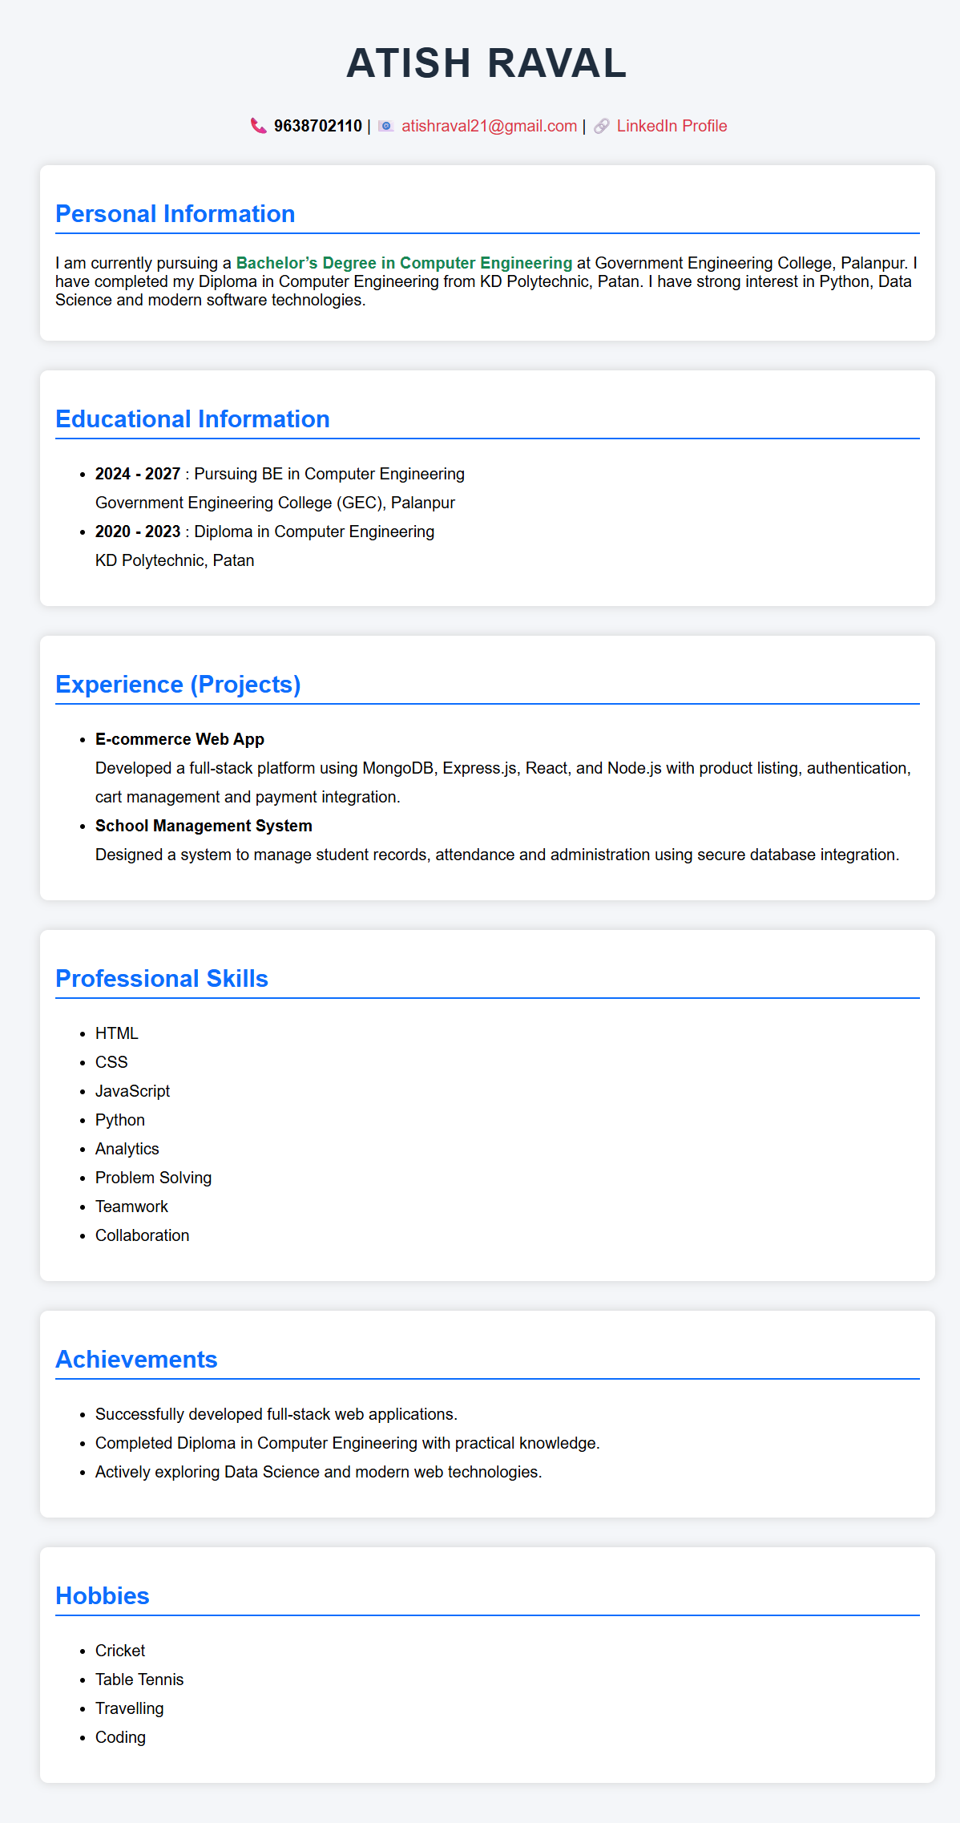

Conclusion:

Quiz:

- Explain HTML Document Structure.

- List and explain any five HTML formatting tags.

- Explain ordered and unordered list with example.

Suggested Reference:

  - https://www.w3schools.com/html/html_basic.asp
  - https://www.w3schools.com/html/html_lists.asp
  - https://www.w3schools.com/html/html_formatting.asp
References used by the students:

Rubric wise marks obtained:

Rubrics | 1 | 2 | 3 | Total
Marks

Experiment No: 2
Create your class time table using table tag, experiment with rowspan, colspan, cellspacing and cellpadding attributes.
Date:

Competency and PracticalSkills:

Relevant CO: 1

Objectives:

- To study HTML table tag
- To study how to organize data in tabular format
Theory:

HTML Table Tag

  - HTML tables allow web developers to arrange data into rows and columns.
  - The <table> tag defines an HTML table.
  - table row is defined with a <tr> tag.
  - table header is defined with a <th> tag.
  - text in <th> elements are bold and centered.
  - Each table data/cell is defined with a <td>.
  - By default, the text in <td> elements are regular and left-aligned.
  - colspan attribute is used to make a cell span more than one column.
  - rowspanattriute is used to make a call span more than one row.
  - cellpadding represents the distance between cell borders and the content within a cell.
  - The cellspacing attribute defines space between table cells.
  - Example
    - Below code is for arranging car details in tabular format.
    - You may stude table tag and output as below.

Code |  |  | Output
 |  |  | 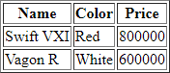
<table border="1">
<tr>
<th>Name</th>
<th>Color</th>
<th>Price</th>
</tr>
<tr>
<td>Swift VXI</td>
<td>Red</td>
<td>800000</td>
</tr>
<tr>
<td>Vagon R</td>
<td>White</td>
<td>600000</td>
</tr>
</table>

Implementation:
Create your class time table using table tag, experiment with rowspan, colspan, cellspacing and cellpadding attributes.

<!DOCTYPE html>
<html>
<head>
<title>SEM VI Time Table</title>
</head>

<body bgcolor="white">

<h2 align="center">Government Engineering College, Palanpur</h2>
<h3 align="center">Computer Engineering Department</h3>
<h3 align="center">Semester VI Time Table (AY 2025-26)</h3>

<table border="2" align="center" cellpadding="10" cellspacing="6" width="95%" bgcolor="white">

<tr align="center" bgcolor="white">
<th>Time</th>
<th>Monday</th>
<th>Tuesday</th>
<th>Wednesday</th>
<th>Thursday</th>
<th>Friday</th>
</tr>

<tr align="center" bgcolor="white">
<th>10:30 - 11:30</th>
<td>AJP (RRP)<br>(8012)</td>
<td>AJP (RRP)<br>(8012)</td>
<td>TOC (RRP)<br>(8012)</td>
<td>WP (RRP)<br>(8012)</td>
<td>MPI (KMG)<br>(8012)</td>
</tr>

<tr align="center" bgcolor="white">
<th>11:30 - 12:30</th>
<td>LIBRARY</td>
<td>TOC (RRP)<br>(8012)</td>
<td>IOT (RHJ)<br>(8012)</td>
<td>MPI (KMG)<br>(8012)</td>
<td>WP (RRP)<br>(8012)</td>
</tr>

<!-- Recess Row -->
<tr bgcolor="white">
<th align="center">12:30 - 1:00</th>
<td colspan="5" align="center"><b>RECESS</b></td>
</tr>

<tr align="center" bgcolor="white">
<th>1:00 - 2:00</th>
<td>IOT (RHJ)<br>(8012)</td>
<td>MPI (KMG)<br>(8012)</td>
<td>---</td>
<td>---</td>
<td>TOC TUT (RRP/VF)<br>(8112)</td>
</tr>

<tr align="center" bgcolor="white">
<th>2:00 - 3:00</th>
<td>TOC (RRP)<br>(8012)</td>
<td>WP (RRP)<br>(8012)</td>
<td>---</td>
<td>---</td>
<td>AJP (RRP)<br>(8012)</td>
</tr>

<tr align="center" bgcolor="white">
<th>3:10 - 4:10</th>
<td>---</td>
<td>---</td>
<td>IPDC (CGP)<br>(8012)</td>
<td>TOC (RRP)<br>(8012)</td>
<td rowspan="2" align="center">LIBRARY</td>
</tr>

<tr align="center" bgcolor="white">
<th>4:10 - 5:10</th>
<td>---</td>
<td>---</td>
<td>IPDC (CGP)<br>(8012)</td>
<td>LIBRARY</td>
</tr>

</table>

</body>
</html>

Output:
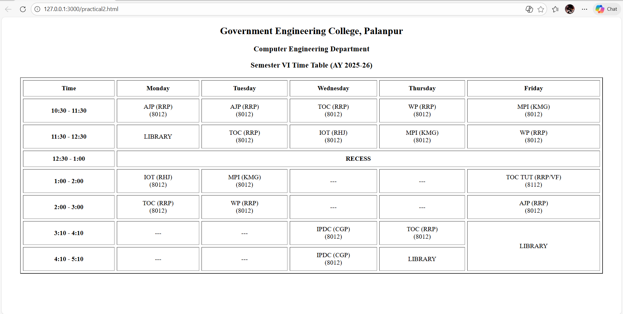

Conclusion:

Quiz:

- Explain the use of rowspan and colspan attributes in table tag.

- Differentiate between <td> and <th>.

Suggested Reference:

  - https://www.w3schools.com/html/html_tables.asp

References used by the students: (Sufficient space to be provided)

Rubric wise marks obtained:

Rubrics | 1 | 2 | 3 | Total
Marks

Experiment No: 3
Design static web pages for your college containing a description of the courses, departments, faculties, library etc. Provide links for navigation among pages.
Date:

Competency and PracticalSkills:

Relevant CO: 1

Objectives:

- To study HTML Link.

Theory:

HTML Links:

  - Links allow users to click their way from page to page.
  - User can click on a link and jump to another document.
  - When you move the mouse over a link, the mouse arrow will turn into a little hand.
  - Syntax
    - <a href="url"> link text </a>
  - Example
<a href=http://www.gtu.ac.in / target=”_blank”>Visit GTU</a>
  - links will appear as follows in all browsers:
    - An unvisited link is underlined and blue
    - A visited link is underlined and purple
    - An active link is underlined and red
  - HTML Link Taget Attribute
    - By default, the linked page will be displayed in the current browser window. To change this, you must specify another target for the link.
    - The target attribute specifies where to open the linked document.
    - The target attribute can have one of the following values:
      - _self - Default. Opens the document in the same window/tab as it was clicked
      - _blank - Opens the document in a new window or tab
      - _parent - Opens the document in the parent frame
      - _top - Opens the document in the full body of the window
Implementation:

Design static web pages for your college containing a description of the courses, departments, faculties, library etc. Provide links for navigation among pages.

<!DOCTYPE html>
<html>
<head>
<title>GEC Palanpur</title>

<style>
body {
margin: 0;
font-family: Arial, sans-serif;
background-color: #f2f2f2;
}

/* Header */
.header {
background-color: black;
text-align: center;
padding: 25px;
}

.header h1 {
margin: 0;
font-size: 32px;
color: #FFD700; /* Gold Color */
}

.header h3 {
margin: 5px;
font-weight: normal;
color: #dcdcdc; /* Light Gray */
}

/* Navigation */
.nav {
background-color: #e0e0e0;
text-align: center;
padding: 12px;
}

.nav a {
text-decoration: none;
color: black;
font-weight: bold;
margin: 0 15px;
}

.nav a:hover {
text-decoration: underline;
}

/* Content */
.content {
background-color: white;
margin: 30px;
padding: 25px;
}

.content h2 {
color: black;
}

ul {
list-style-type: square;
}

/* Footer */
.footer {
background-color: #d9d9d9;
text-align: center;
padding: 15px;
margin-top: 20px;
}
</style>
</head>

<body>

<div class="header">
<h1>Government Engineering College, Palanpur</h1>
<h3>Computer Engineering Department</h3>
</div>

<div class="nav">
<a href="#home">Home</a> |
<a href="#departments">Departments & Courses</a> |
<a href="#faculties">Faculties</a> |
<a href="#library">Library</a>
</div>

<div class="content" id="home">

<h2>Welcome to GEC Palanpur</h2>
<p>
Government Engineering College, Palanpur is an institute offering undergraduate
engineering education in Civil, Computer, Mechanical and Electrical branches.
</p>

<p>
The Computer Engineering department focuses on Algorithms,
Web Programming, Network Security, Data Mining and Software Engineering
to build strong technical foundations.
</p>

<h2 id="departments">Departments</h2>

<h3>Civil Engineering</h3>
<p>Construction, structural design and infrastructure development.</p>

<h3>Computer Engineering</h3>
<p>Programming, AI, web technologies and software development.</p>

<h3>Mechanical Engineering</h3>
<p>Machines, manufacturing systems and automobile engineering.</p>

<h3>Electrical Engineering</h3>
<p>Power systems, electrical machines and renewable energy.</p>

<h2>Courses Offered</h2>
<ul>
<li>B.E. Civil Engineering</li>
<li>B.E. Computer Engineering</li>
<li>B.E. Mechanical Engineering</li>
<li>B.E. Electrical Engineering</li>
</ul>

<h2 id="faculties">Faculties</h2>
<ul>
<li>Experienced and qualified faculty members</li>
<li>Industry-oriented teaching approach</li>
<li>Research and project guidance</li>
</ul>

<h2 id="library">Library</h2>
<p>
The Central Library provides textbooks, reference books, journals
and digital learning resources.
</p>

<h2>Why Choose Our College?</h2>
<ul>
<li>Experienced faculty members</li>
<li>Well-equipped laboratories</li>
<li>Active technical clubs</li>
<li>Industry-oriented curriculum</li>
</ul>

</div>

<div class="footer">
© 2026 Government Engineering College, Palanpur
</div>

</body>
</html>

Output:


Conclusion:

Quiz:
- Explain HTML Link target attribute.

- How to use image as a link ?

Suggested Reference:

  - https://www.w3schools.com/html/html_links.asp

References used by the students: Rubric wise marks obtained:
Rubrics | 1 | 2 | 3 | Total
Marks

Experiment No: 4
Create User Registration Form in HTML (Suggested to use fields like Name, Date of Birth, Gender, Email Id, Mobile No,Address, State,Education, Image Upload etc.) using textbox, textarea, checkbox, radio button, select box, button, file upload etc.
Date:

Competency and PracticalSkills:

Relevant CO: 1 Objectives:
- To study HTML Form Tag.
- To Study Various Input Types like textbox, password, radio button, checkbox etc.
Theory:
HTML Forms are required, when .
  - For example, for registration you may collect information like user name,email, contact number, address etc.
  - A form will take input from the site visitor and then will post it to a back-end application such as CGI, ASP Script or PHP script etc.
  - The back-end application will perform required processing on the passed data based on defined business logic inside the application.
  - There are various form elements available like text fields, textarea fields, drop-down menus, radio buttons, checkboxes, etc.
  - The HTML <form> tag is used to create an HTML form
  - Syntax:
<form action = "Script URL" method = "GET|POST"> form elements like input, textarea etc.
</form>

  - Important form attributes are as given below

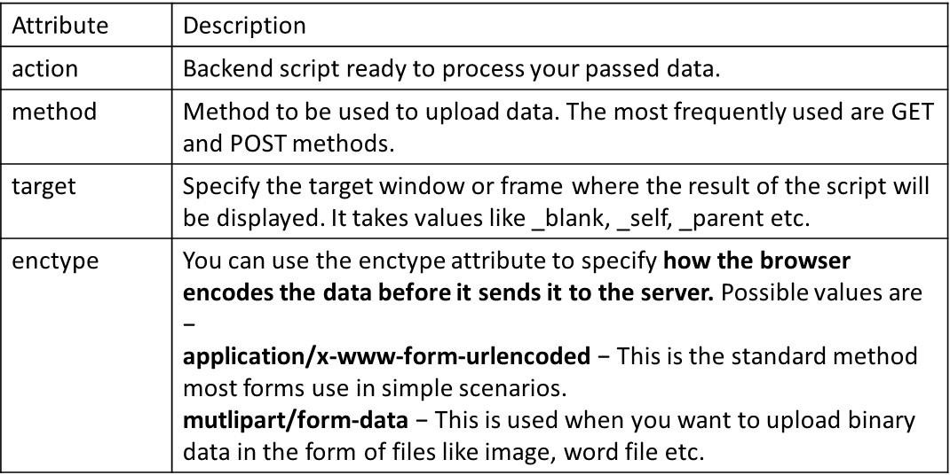

  - HTML Form Controls

Control Name | Used for | Sample Code
Text input control  Single line text input control | Textbox is used for accepting text from user, like firstname,lastname etc. | <input type = "text" name = "first_name" />
Text input control  Password input control | Password input control is used to accept password from user. | <input type = "password" name = "password" />
Text input control  Multiline input control. | Teaxtarea is used to accept multiline text input  , like comments. | <textarea rows = "5" cols = "50" name = "description">  Enter description here...  </textarea>
Checkbox Control | Checkboxes are used when more than one option is required to be selected. |  | <input type = "checkbox" name = "maths" value = “maths"> Maths  <input type = "checkbox" name = "physics" value = “physics">name = "password" />

Radio Button Controls | Radio buttons are used when out of many options, just one option is required to be selected. | <input type = "radio" name = "subject" value = "maths"/> Maths  <input type = "radio" name = "subject" value = "physics"/> Physics
Drop Down box Control | provides option to list down various options in the form of drop down list, from where a user can select one or more options. | <select name = "dropdown">  <option value = "Maths" selected>Maths</option>  <option value = "Physics">Physics</option>  </select>
File Upload | It allows site users to upload a file to website.it is also known as file select box. | <input type = "file" name = "fileupload" accept = "image/*" />
Button Control  Submit | This creates a button that automatically submits a form. | <input type = "submit" name = "submit" value = "Submit" />
Button Control  Reset | This creates a button that automatically resets form controls to their initial values. | <input type = "reset" name = "reset" value = "Reset" />
Button Control  Button | This creates a button that is used to trigger a client- side script when the user clicks that button. |  | <input type = "button" name = "ok" value = "OK" />

Button Control  Image | This creates a clickable button but we can use an image as background of the button. |  | <input type = "image" name = "imagebutton" src = "/html/images/logo.png" />
Hidden Control | Hidden form controls are used to hide data inside the page which later on can be pushed to the server. This control hides inside the code and does not appear on the actual page. |  | <input type = "hidden" name = "pagename" value = "10" />
Implementation:
Create User Registration Form in HTML (Suggested to use fields like Name, Date of Birth, Gender, Email Id, Mobile No., Address, State,Education, Image Upload etc.) using textbox, textarea, checkbox, radio button, select box, button, file upload etc.

<!DOCTYPE html>
<html>
<head
<title>User Registration Form</title>
<style>
body {
background-color: #f2f2f2;
font-family: Arial;
}
table {
background-color: white;
}
input[type="checkbox"],
input[type="radio"] {
accent-color: black;
}
</style>
</head>
<body>
<h2 align="center">User Registration Form</h2>
<form>
<table align="center" cellpadding="8" cellspacing="5" border="1">
<tr>
<td>Full Name:</td>
<td>
<input type="text" name="name" value="Atish Raval" required>
</td>
</tr>
<tr>
<td>Date of Birth:</td>
<td>
<input type="date" name="dob" value="2004-05-18">
</td>
</tr>

<tr>
<td>Gender:</td>
<td>
<input type="radio" name="gender" checked> Male
<input type="radio" name="gender"> Female
<input type="radio" name="gender"> Other
</td>
</tr>

<tr>
<td>Email ID:</td>
<td>
<input type="email" name="email"
value="240613107023@gecpalanpur.ac.in" required>
</td>
</tr>

<tr>
<td>Mobile No:</td>
<td>
<input type="text" name="mobile" value="9638702110" required>
</td>
</tr>

<tr>
<td>Address:</td>
<td>
<textarea rows="4" cols="35">
B-61 Om Housing Society,
Opp-Gokul Party Plot,
Nr-Nilamber Circle, Vasna-Bhayli Road,
Vasna, Vadodara - 390015
</textarea>
</td>
</tr>

<tr>
<td>State:</td>
<td>
<input type="text" value="Gujarat">
</td>
</tr>

<tr>
<td>District:</td>
<td>
<input type="text" value="Vadodara">
</td>
</tr>

<tr>
<td>Education:</td>
<td>
<input type="checkbox" checked>
BE in Computer Engineering (GEC Palanpur)
</td>
</tr>

<tr>
<td>Hobbies:</td>
<td>
<input type="checkbox" checked> Cricket
<input type="checkbox" checked> Table Tennis
<input type="checkbox" checked> Travelling
<input type="checkbox" checked> Coding
<input type="checkbox"> Watching Anime
<input type="checkbox"> cooking
</td>
</tr>

<tr>
<td>Upload Profile Image:</td>
<td>
<input type="file">
</td>
</tr>

<tr align="center">
<td colspan="2">
<input type="submit" value="Register">
<input type="reset" value="Clear">
</td>
</tr>
</table>
</form>
</body>
</html>

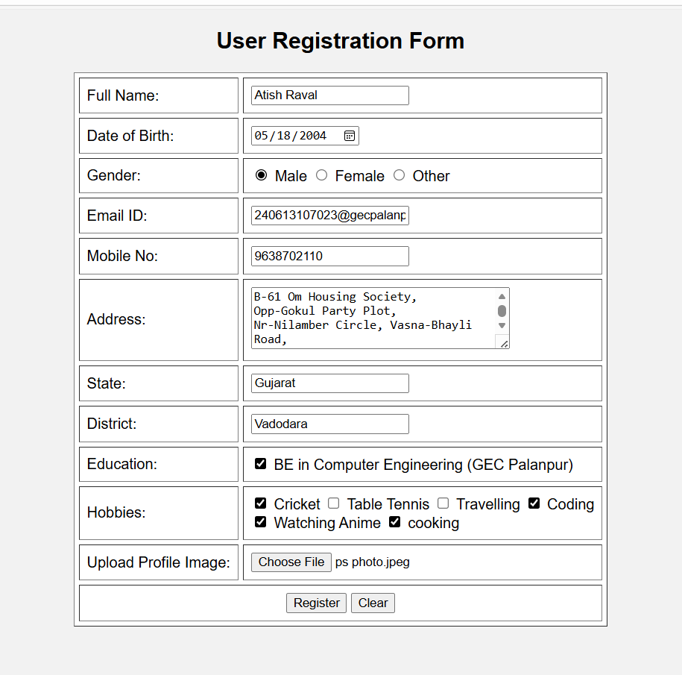Output:
Conclusion:

Quiz:
- Explain form tag with its attributes.

- Differentiate between text input and password input controls.

- Explain various types of buttons available in HTML.

Suggested Reference:

  - https://www.w3schools.com/html/html_forms.asp

References used by the students:

Rubric wise marks obtained:

Rubrics | 1 | 2 | 3 | Total
Marks

Experiment No: 5
Create two web pages, one contains audios and other page contains videos (using HTML5 audio and video tags). Also provide link for navigation between pages.
Date:

Competency and PracticalSkills:

Relevant CO: 1

Objectives:
- To study how to add audio and video content in html page.

Theory:

HTML Video

The HTML <video> element is used to show a video on a web page.

Example:
<video width="320" height="240" controls>
<source src="movie.mp4" type="video/mp4">
<source src="movie.ogg" type="video/ogg"> Your browser does not support the video tag.
</video>

The controls attribute adds video controls, like play, pause, and volume.

The <source> element allows you to specify alternative video files which the browser may choose from. The browser will use the first recognized format.
The text between the <video> and </video> tags will only be displayed in browsers that do not support the <video> element.
HTML Audio
The HTML <audio> element is used to play an audio file on a web page.
<audio controls>
<source src="horse.ogg" type="audio/ogg">
<source src="horse.mp3" type="audio/mpeg"> Your browser does not support the audio element.
</audio>

The controlsattribute adds audio controls, like play, pause, and volume.

The <source> element allows you to specify alternative audio files which the browser may choose from. The browser will use the first recognized format.
Implementation:
Create two web pages, one contains audios and other page contains videos (using HTML5 audio and video tags). Also provide link for navigation between pages.
AUDIO FILE:

<!DOCTYPE html>
<html>
<head>
<title>Audio Page</title>
</head>

<body bgcolor="#f2f2f2">

<h1 align="center">Audio Gallery</h1>
<hr>

<h3>Audio-1 Perfact</h3>
<audio controls>
<source src="audio1.mpeg" type="audio/mpeg">
Your browser does not support the audio element.
</audio>

<br><br>

<h3>Audio-2 Pal</h3>
<audio controls>
<source src="audio2.mpeg" type="audio/mpeg">
Your browser does not support the audio element.
</audio>

<h3>Audio-3 Aadat</h3>
<audio controls>
<source src="audio3.mpeg" type="audio/mpeg">
Your browser does not support the audio element.
</audio>

<br><br>
<hr>
</body>
</html>

VIDEO FILE:
<!DOCTYPE html>
<html>
<head>
<title>Video Page</title>
</head>

<body bgcolor="#ffffff">

<h1 align="center">Video Gallery</h1>
<hr>

<h3>Sample Video Chapter-1</h3>
<video width="400" height="300" controls>
<source src="Chapter-1.mp4" type="video/mp4">
Your browser does not support the video tag.
</video>

<br><br>

<h3>Sample Video Chapter-2</h3>
<video width="400" height="300" controls>
<source src="chapter-2.mp4" type="video/mp4">
Your browser does not support the video tag.
</video>

<br><br>
<hr>

</body>
</html>

Output:
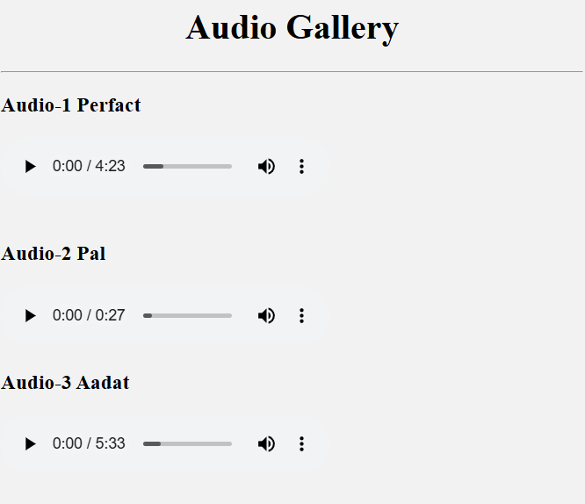

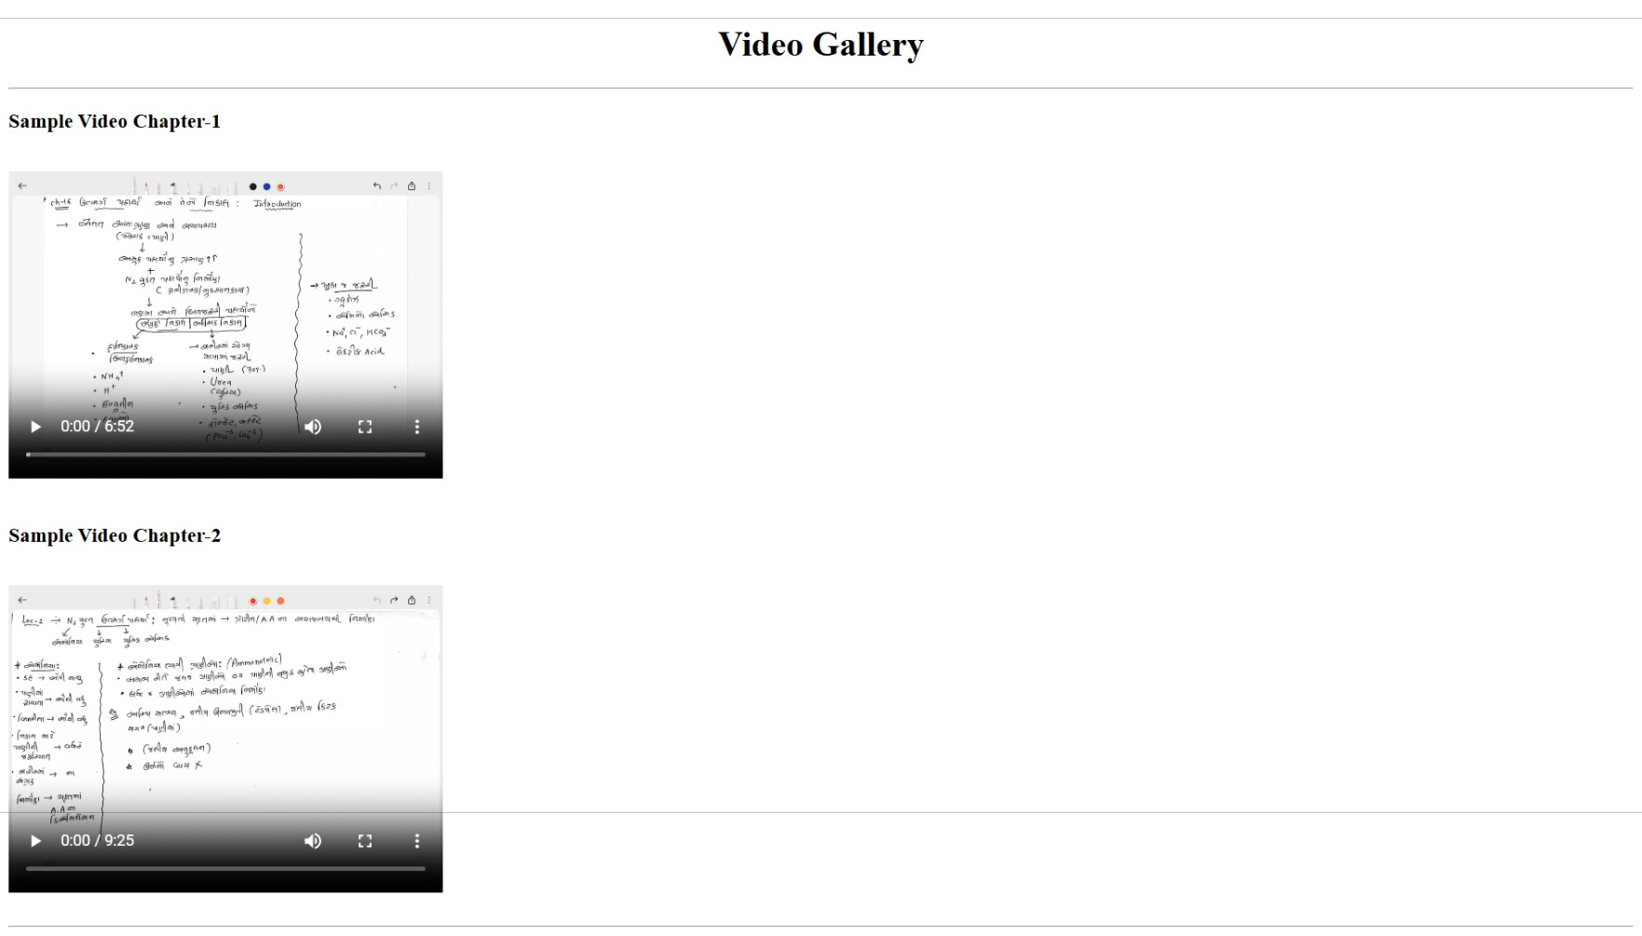
Conclusion:

Quiz:

- Explain audio and video tags.

Suggested Reference:

  - https://www.w3schools.com/html/html_media.asp

References used by the students:

Rubric wise marks obtained:

Rubrics | 1 | 2 | 3 | Total
Marks

Experiment No: 6
Create a web page using frame. Divide the page into two parts with Navigation links on left hand side of page (width=20%) and content page on right hand side of page (width = 80%). On clicking the navigation Links corresponding content must be shown on the right-hand side.
Date:

Competency and PracticalSkills:

Relevant CO: 1

Objectives:

- To study frame and frameset to divide page multiple sections.
- To understand about use of target attribute to open web page in target frame.
Theory:
The <frame> tag was used in HTML 4 to define one particular window (frame) within a
<frameset>
HTML frames are used to divide your browser window into multiple sections where each section can load a separate HTML document.
A collection of frames in the browser window is known as a frameset.
The window is divided into frames in a similar way the tables are organized: into rows and columns.
Creating Frames

To use frames on a page we use <frameset> tag instead of <body> tag.
The <frameset> tag defines, how to divide the window into frames. The rows attribute of
<frameset> tag defines horizontal frames and cols attribute defines vertical frames.
Each frame is indicated by <frame> tag and it defines which HTML document shall open into the frame.
The <frameset> Tag Attributes
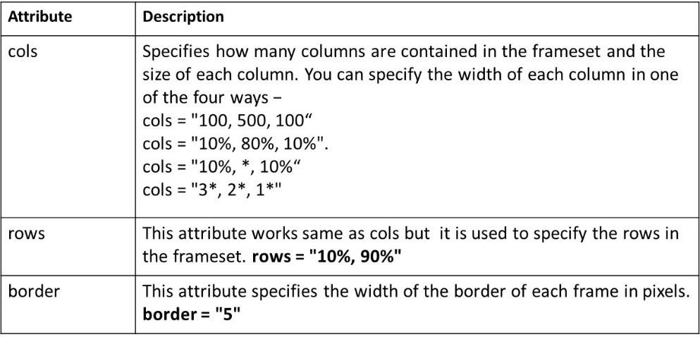

Example: example to create three horizontal frames
<frameset rows = "10%,80%,10%">
<frame name = "top" src = "./rows_demo_pages/top_frame.htm" />
<frame name = "main" src = "./rows_demo_pages/main_frame.htm" />
<frame name = "bottom" src = "./rows_demo_pages/bottom_frame.htm" />
<noframes>
<body>Your browser does not support frames. </body>
</noframes>

</frameset>

In below implementation use target attribute in navigation link to open page in specific frame.

Implementation:

Create a web page using frame. Divide the page into two parts with Navigation links on left hand side of page (width=20%) and content page on right hand side of page (width = 80%). On clicking the navigation Links corresponding content must be shown on the right-hand side.

<!DOCTYPE html>
<html lang="en">
<head>
<meta charset="UTF-8">
<title>GEC Palanpur - Frame Style Layout</title>

<style>

/* Background */
body{
margin:0;
font-family:Arial, sans-serif;
background:linear-gradient(135deg,#1e3c72,#2a5298);
}

/* Main Layout */
.container{
display:flex;
height:100vh;
}

/* Left Navigation (20%) */
.menu{
width:20%;
background:rgba(0,0,0,0.5);
color:white;
padding:25px;
}

/* Menu Heading */
.menu h2{
text-align:center;
margin-bottom:25px;
}

/* Menu Links */
.menu a{
display:block;
text-decoration:none;
color:white;
padding:12px;
margin:12px 0;
border-radius:6px;
background:rgba(255,255,255,0.1);
transition:0.3s;
}

.menu a:hover{
background:#00c6ff;
color:black;
}

/* Right Content (80%) */
.content{
width:80%;
padding:40px;
color:white;
}

/* Content Card */
.section{
background:rgba(255,255,255,0.15);
padding:30px;
border-radius:12px;
}

.section ul{
padding-left:20px;
}

</style>
</head>

<body>

<div class="container">

<!-- Navigation -->
<div class="menu">

<h2>College Menu</h2>

<a href="#" onclick="loadPage('home')">Home</a>
<a href="#" onclick="loadPage('courses')">Courses</a>
<a href="#" onclick="loadPage('faculty')">Faculty</a>
<a href="#" onclick="loadPage('library')">Library</a>

</div>

<!-- Content -->
<div class="content">

<div id="display" class="section">

<h1>Welcome</h1>
<p>Select any option from the left navigation menu.</p>

</div>

</div>

</div>

<script>

/* Function to change content */

function loadPage(page){

let content="";

if(page==="home"){
content=`
<h1>Welcome to GEC Palanpur</h1>
<p>
Government Engineering College Palanpur is a reputed institute in Gujarat.
It provides quality technical education and practical learning environment.
</p>

<ul>
<li>Modern Laboratories</li>
<li>Experienced Faculty</li>
<li>Industry Oriented Curriculum</li>
</ul>
`;
}

if(page==="courses"){
content=`
<h1>Courses Offered</h1>

<ul>
<li>Computer Engineering</li>
<li>Civil Engineering</li>
<li>Mechanical Engineering</li>
<li>Electrical Engineering</li>
</ul>

<p>All programs focus on practical and theoretical knowledge.</p>
`;
}

if(page==="faculty"){
content=`
<h1>Faculty Members</h1>

<ul>
<li>Experienced Professors</li>
<li>Assistant Professors</li>
<li>Research Scholars</li>
</ul>

<p>Faculty members guide students in academics and projects.</p>
`;
}

if(page==="library"){
content=`
<h1>Library Facilities</h1>

<ul>
<li>Reference Books</li>
<li>Technical Journals</li>
<li>Digital Library</li>
<li>Reading Hall</li>
</ul>

<p>The library supports students with learning resources.</p>
`;
}

document.getElementById("display").innerHTML=content;

}

</script>

</body>
</html>

Output:



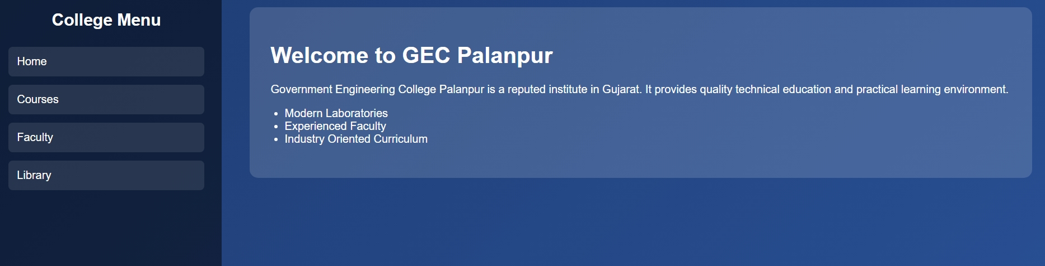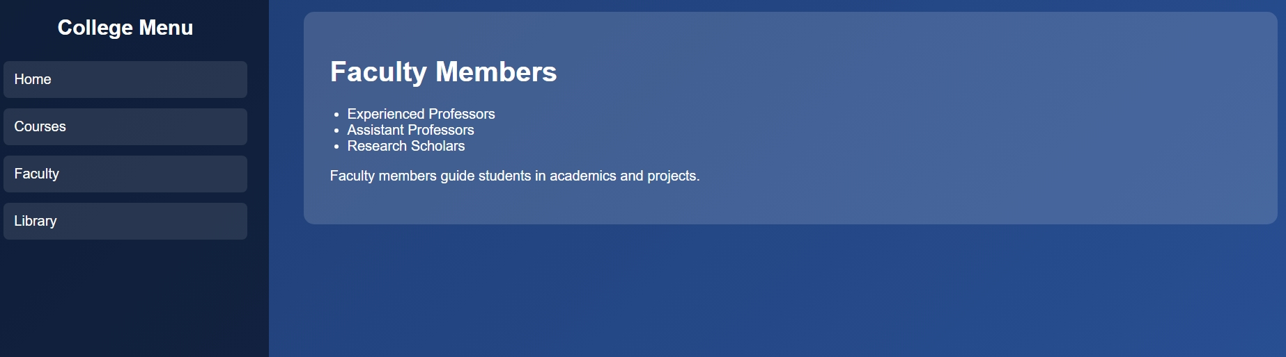



Conclusion:

Quiz:

- Explain about rows and cols attribute of frame tag.

- Which tag embed an inline frame in a web page?

- Which attribute in frame tag is used to specifies the web page to load into that frame?

Suggested Reference:

  - https://www.w3schools.com/tags/tag_frameset.asp

References used by the students:

Rubric wise marks obtained:

Rubrics | 1 | 2 | 3 | Total
Marks

Experiment No: 7
Design a web page of your home town with an attractive background color, text color, an Image, font etc. (use internal CSS).
Date:

Competency and PracticalSkills:

Relevant CO: 1

Objectives:

- To understand how CSS works.

Theory:

Introduction To CSS

  - CSS stands for Cascading Style Sheets
  - CSS describes how HTML elements are to be displayed.
  - CSS saves a lot of work. It can control the layout of multiple web pages all at once
  - External stylesheets are stored in CSS files
  - HTML was NEVER intended to contain tags for formatting a web page! HTML was created to describe the content of a web page.
  - When tags like <font>, and color attributes were added to the HTML 3.2 specification, it started a nightmare for web developers. Development of large websites, where fonts and color information were added to every single page, became a long and expensive process.
  - To solve this problem, the World Wide Web Consortium (W3C) created CSS.
  - CSS removed the style formatting from the HTML page!
CSS Syntax
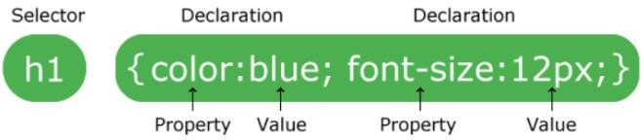

  - A CSS rule-set consists of a selector and a declaration block:
  - The selector points to the HTML element you want to style.
  - The declaration block contains one or more declarations separated by semicolons.
  - Each declaration includes a CSS property name and a value, separated by a colon.
  - declaration blocks are surrounded by curly braces.
Example:In this example all <p> elements will be center-aligned, with a red text color

Code | Output
<!DOCTYPE html>  <html>  <head>  <style> p {  color: red;  text-align: center;  }  </style>  </head>  <body>  <p>Hello World!</p>  <p>These paragraphs are styled with CSS.</p>  </body>  </html> | 
  - p is a selector in CSS (it points to the HTML element you want to style: <p>).
  - color is a property, and red is the property value
  - text-align is a property, and center is the property value
CSS Selectors

  - CSS Element Selector
    - The element selector selects HTML elements based on the element name.
    - Example:

p {
text-align: center; color: red;
}
  - The CSS id Selector

    - The id selector uses the id attribute of an HTML element to select a specific element.
    - The id of an element is unique within a page, so the id selector is used to select one unique element!
    - To select an element with a specific id, write a hash (#) character, followed by the id of the element.
    - Example

<!DOCTYPE html>
<html>
<head>
<style> #para1 {
text-align: center; color: red;
}
</style>
</head>
<body>
<p id="para1">Hello World!</p>
<p>This paragraph is not affected by the style.</p>
</body>
</html>
  - CSS Class Selector
    - The class selector selects HTML elements with a specific class attribute.
    - To select elements with a specific class, write a period (.) character, followed by the class name.
    - Example
      - In this example all HTML elements with class="center" will be red and center-aligned:

<!DOCTYPE html>
<html>
<head>
<style>
.center {
text-align: center; color: red;
}
</style>
</head>
<body>
<h1 class="center">Red and center- aligned heading</h1>
<p class="center">Red and center- aligned paragraph.</p>
</body>
</html>
  - CSS Universal Selector
    - The universal selector (*) selects all HTML elements on the page.
    - Example
  - ​
<!DOCTYPE html>
<html>
<head>
<style>
* {
text-align: center; color: blue;
}
</style>
</head>
<body>
<h1>Hello world!</h1>
<p>Every element on the page will be affected by the style.</p>
<p id="para1">Me too!</p>
<p>And me!</p>
</body>
</html>

  - CSS Grouping Selector

    - The grouping selector selects all the HTML elements with the same style definitions.
    - To group selectors, separate each selector with a comma.
    - Example:

h1, h2, p {
text-align: center; color: red;
}
  - The CSS Pseudo Class Selector

    - Some selectors can be considered different because of the way the element they belong to works.
    - For example, the anchor that creates a link between documents can have pseudo classes attached to it simply because it is not known at the time of writing the markup what the state will be.
    - It could be visited, not visited, or in the process of being selected.
    - CSS pseudo-classes are used to add special effects to some selectors. You do not need to use JavaScript or any other script to use those effects.
    - selector: pseudo-class {property: value}
    - CSS classes can also be used with pseudo-classes
    - selector.class: pseudo-class {property: value}
    - Example

o | a : link { color: red}  a : active { color: yellow} a : visited { color: green}  a : hover { font-weight: bold}  a : link : hover {font-weight:bold}

  - Types Of CSS
    - External CSS
    - Internal CSS
    - Inline CSS
  - Internal CSS
    - An internal style sheet may be used if one single HTML page has a unique style.
    - The internal style is defined inside the <style> element, inside the head section.
    - Example:

<!DOCTYPE html>
<html>
<head>
<style> body {
background-color: linen;
}
h1 {
color: maroon; margin-left: 40px;
}
</style>
</head>
<body>
<h1>This is a heading</h1>
<p>This is a paragraph.</p>
</body>
</html>
-CSS Background Color
- The background-color property specifies the background color of an element.
- With CSS, a color is most often specified by:
  - a valid color name - like "red"
  - a HEX value - like "#ff0000"
  - an RGB value - like "rgb (255,0,0)"
Example:

body {
background-color: lightblue;
}
-CSS Text Color
  - text color can be set using color property
Example:

<h1 style="color:Tomato;">Hello World</h1>
Implementation:
Design a web page of your home town with an attractive background color, text color, an Image, font etc. (use internal CSS).

<!DOCTYPE html>
<html lang="en">
<head>
<meta charset="UTF-8">
<title>Vadodara - My Hometown</title>

<style>

body{
margin:0;
font-family:"Segoe UI", Arial, sans-serif;
background:linear-gradient(135deg,#0f172a,#1d4ed8);
color:#f9fafb;
}

/* Animation */
@keyframes fadeInUp{
from{opacity:0; transform:translateY(20px);}
to{opacity:1; transform:translateY(0);}
}

@keyframes floatImage{
0%{transform:translateY(0);}
50%{transform:translateY(-8px);}
100%{transform:translateY(0);}
}

/* Header */
.header{
text-align:center;
padding:25px 10px;
background:rgba(15,23,42,0.9);
box-shadow:0 2px 6px rgba(0,0,0,0.4);
}

.header h1{
margin:0;
font-size:36px;
letter-spacing:2px;
text-transform:uppercase;
}

.header p{
margin:5px 0 0;
font-size:16px;
opacity:0.85;
}

/* Container */
.container{
max-width:1100px;
margin:25px auto;
background-color:rgba(15,23,42,0.88);
border-radius:12px;
padding:20px 30px;
box-shadow:0 4px 16px rgba(0,0,0,0.5);
animation:fadeInUp 0.9s ease-out;
}

/* Top section */
.top-section{
display:flex;
flex-wrap:wrap;
gap:20px;
align-items:center;
}

.top-text{
flex:1 1 320px;
}

.top-text h2{
margin-top:0;
font-size:26px;
color:#38bdf8;
border-bottom:2px solid #38bdf8;
display:inline-block;
padding-bottom:4px;
}

.top-text p{
line-height:1.7;
}

.tag-line{
margin-top:15px;
font-style:italic;
color:#a5b4fc;
}

/* Image */
.image-box{
flex:1 1 260px;
text-align:center;
}

.image-box img{
width:100%;
max-width:380px;
border-radius:10px;
border:3px solid #38bdf8;
box-shadow:0 4px 12px rgba(0,0,0,0.6);
animation:floatImage 4s ease-in-out infinite;
}

/* Sections */
.section{
margin-top:20px;
}

.section h3{
color:#fde68a;
margin-bottom:8px;
}

/* Places Grid */
.places-grid{
display:grid;
grid-template-columns:repeat(auto-fit,minmax(180px,1fr));
gap:15px;
margin-top:12px;
}

/* Place Card */
.place-card{
background-color:rgba(30,64,175,0.9);
border-radius:10px;
overflow:hidden;
box-shadow:0 3px 8px rgba(0,0,0,0.4);
transition:transform 0.25s ease, box-shadow 0.25s ease;
}

.place-card img{
width:100%;
height:130px;
object-fit:cover;
display:block;
}

.place-card-content{
padding:8px 10px 10px;
}

.place-card h4{
margin:0 0 4px;
color:#facc15;
font-size:16px;
}

.place-card p{
margin:0;
font-size:13px;
line-height:1.5;
}

.place-card:hover{
transform:translateY(-6px) scale(1.02);
box-shadow:0 6px 18px rgba(0,0,0,0.6);
}

/* Footer */
.footer{
text-align:center;
padding:12px 0 20px;
font-size:13px;
color:#cbd5f5;
}

</style>

</head>

<body>

<div class="header">
<h1>Vadodara, Gujarat</h1>
<p>My hometown in Central Gujarat</p>
</div>

<div class="container">

<div class="top-section">

<div class="top-text">

<h2>About Vadodara</h2>

<p>
Vadodara, also known as Baroda, is one of the most important cultural
and educational cities in Gujarat. It is famous for its royal heritage,
beautiful gardens and historic palaces.
</p>

<p>
The city was ruled by the Gaekwad dynasty and is known for
Laxmi Vilas Palace, which is one of the largest private
residences in the world.
</p>

<p class="tag-line">
Vadodara is known for its culture, education and vibrant
Navratri celebrations.
</p>

</div>

<div class="image-box">
<img src="vadodara_city.jpg">
</div>

</div>

<div class="section">

<h3>Top 5 Places to Visit in Vadodara</h3>

<div class="places-grid">

<div class="place-card">
<img src="lakshmi_vilas.jpg">
<div class="place-card-content">
<h4>Laxmi Vilas Palace</h4>
<p>Magnificent palace of the Gaekwad dynasty and the most famous landmark of Vadodara.</p>
</div>
</div>

<div class="place-card">
<img src="sayaji_garden.jpg">
<div class="place-card-content">
<h4>Sayaji Garden</h4>
<p>Also known as Kamati Baug, one of the largest gardens in Western India.</p>
</div>
</div>

<div class="place-card">
<img src="baroda_museum.webp">
<div class="place-card-content">
<h4>Baroda Museum</h4>
<p>A famous museum with art, history and cultural collections.</p>
</div>
</div>

<div class="place-card">
<img src="sursagar_lack.jpg">
<div class="place-card-content">
<h4>Sursagar Lake</h4>
<p>Popular lake in the center of Vadodara with a huge Shiva statue.</p>
</div>
</div>

<div class="place-card">
<img src="kirti_mandir.jpg">
<div class="place-card-content">
<h4>Kirti Mandir</h4>
<p>A historical memorial built by the Gaekwad royal family.</p>
</div>
</div>

</div>

</div>

</div>

<div class="footer">
© 2026 My Hometown – Vadodara, Gujarat
</div>

</body>
</html>

Output:
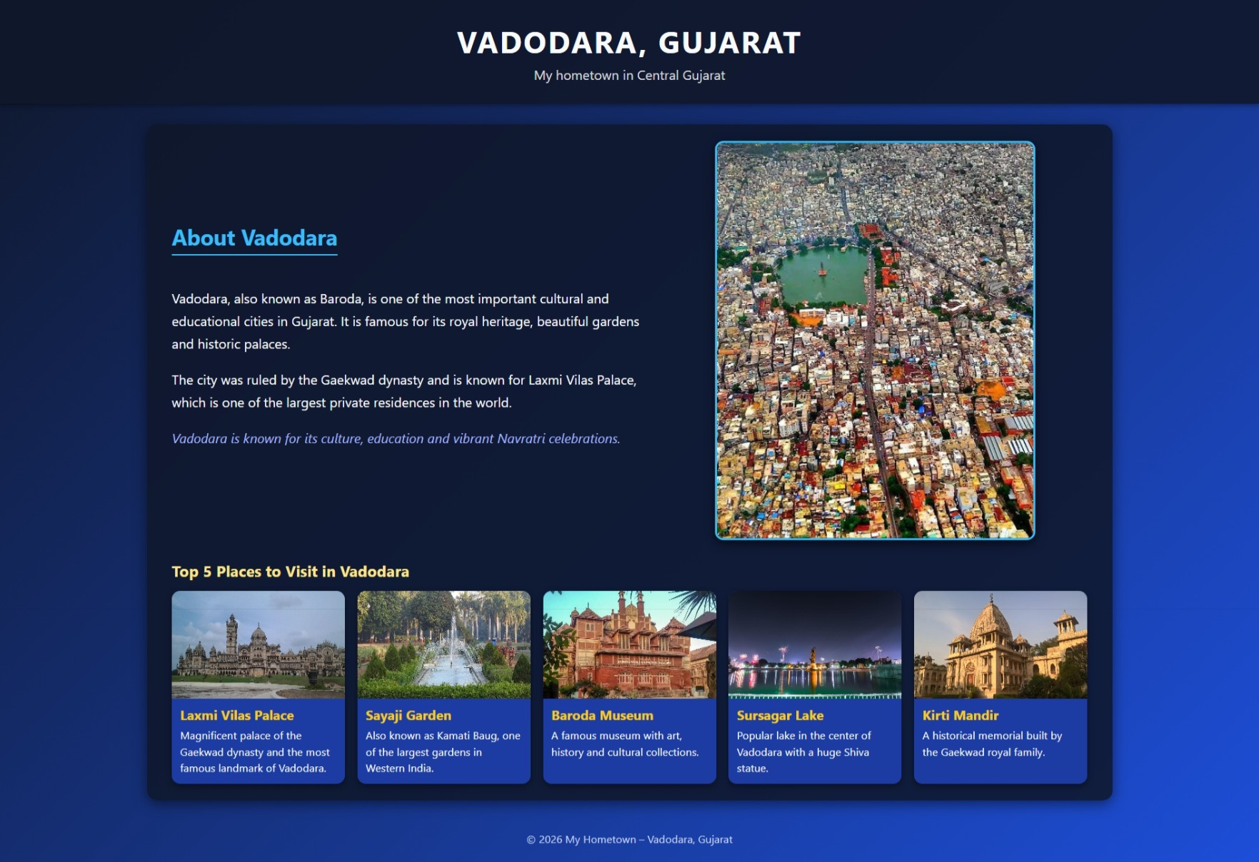

Conclusion:

Quiz:

1.Explain the syntax of the CSS.

2.What is internal CSS?

3.Explain CSS class and Id selector.

Suggested Reference:

  - https://www.w3schools.com/css/css_syntax.asp
  - https://www.geeksforgeeks.org/types-of-css-cascading-style-sheet/
References used by the students:

Rubric wise marks obtained:

Rubrics | 1 | 2 | 3 | Total
Marks

Experiment No: 8
Use Inline CSS to format your resume that you created in practical no 01.
Date:

Competency and PracticalSkills:

Relevant CO: 1 Objectives:
- To understand the use of Inline CSS.
Theory:

Internal CSS

  - An inline style may be used to apply a unique style for a single element.
  - To use inline styles, add the style attribute to the relevant element. The style attribute can contain any CSS property.
Example:

<!DOCTYPE html>
<html>
<body>
<h1 style="color:blue;text-align:center;">This is a heading</h1>
<p style="color:red;">This is a paragraph.</p>
</body>
</html>

Implementation:

Use Inline CSS to format your resume that you created in practical no 01.

<!DOCTYPE html>
<html lang="en">
<head>
<meta charset="UTF-8">
<title>Atish Raval - Resume</title>
</head>

<body style="margin:0; font-family:Arial, sans-serif; background-color:#f4f4f4;">

<!-- Outer Container -->
<div style="max-width:900px; margin:20px auto; background-color:#ffffff;
border-radius:8px; box-shadow:0 0 10px rgba(0,0,0,0.15); padding:20px 30px;">

<!-- Header -->
<div style="text-align:center; border-bottom:2px solid #0066cc;
padding-bottom:10px; margin-bottom:15px;">

<h1 style="margin:0; font-size:32px; color:#0066cc; letter-spacing:1px;">
ATISH RAVAL
</h1>

<p style="margin:5px 0 0; font-size:14px; color:#555555;">
Computer Engineering Student · Web Development & Data Science Enthusiast
</p>

<p style="margin:3px 0 0; font-size:13px; color:#555555;">
Email:
<a href="mailto:atishraval21@gmail.com"
style="color:#cc0000; text-decoration:none;">
atishraval21@gmail.com
</a>
· Mobile:
<span style="color:#222222;">9638702110</span>
</p>

</div>

<!-- About Me -->
<h2 style="font-size:20px; color:#004499; margin:10px 0;
border-bottom:1px solid #dddddd; padding-bottom:4px;">
About Me
</h2>

<p style="margin:4px 0; font-size:14px; color:#444444;">
I am currently pursuing a Bachelor's degree in Computer Engineering at
Government Engineering College, Palanpur. I completed my Diploma in
Computer Engineering from KD Polytechnic, Patan. I have strong interest
in Python, Data Science and exploring various computer software
technologies. I am eager to enhance my technical skills and apply my
knowledge to practical and innovative projects.
</p>

<!-- Education -->
<h2 style="font-size:20px; color:#004499; margin:16px 0 8px;
border-bottom:1px solid #dddddd; padding-bottom:4px;">
Educational Information
</h2>

<ul style="margin:5px 0 5px 20px; font-size:14px; color:#444444;">
<li style="margin-bottom:4px;">
<b>2020 – 2023 :</b> Diploma in Computer Engineering – KD Polytechnic, Patan
</li>

<li style="margin-bottom:4px;">
<b>2024 – 2027 :</b> Pursuing B.E. in Computer Engineering – Government Engineering College, Palanpur
</li>
</ul>

<!-- Projects -->
<h2 style="font-size:20px; color:#004499; margin:16px 0 8px;
border-bottom:1px solid #dddddd; padding-bottom:4px;">
Projects
</h2>

<ul style="margin:5px 0 5px 20px; font-size:14px; color:#444444;">

<li style="margin-bottom:5px;">
<b>E-commerce Web App</b> – Developed a full-stack e-commerce platform
using MongoDB, Express.js, React and Node.js with features like
product listing, user authentication, cart management and payment integration.
</li>

<li style="margin-bottom:5px;">
<b>School Management System</b> – Designed and developed a system to
manage student records, attendance and administration using secure
database integration and a user-friendly interface.
</li>

</ul>

<!-- Skills -->
<h2 style="font-size:20px; color:#004499; margin:16px 0 8px;
border-bottom:1px solid #dddddd; padding-bottom:4px;">
Skills
</h2>

<ul style="margin:5px 0 5px 20px; font-size:14px; color:#444444;">
<li>HTML</li>
<li>CSS</li>
<li>JavaScript</li>
<li>Python</li>
<li>Analytics</li>
<li>Problem Solving</li>
<li>Teamwork</li>
<li>Collaboration</li>
</ul>

<!-- Hobbies -->
<h2 style="font-size:20px; color:#004499; margin:16px 0 8px;
border-bottom:1px solid #dddddd; padding-bottom:4px;">
Hobbies
</h2>

<ul style="margin:5px 0 5px 20px; font-size:14px; color:#444444;">
<li>Cricket</li>
<li>Table Tennis</li>
<li>Travelling</li>
<li>Coding</li>
</ul>

</div>

</body>
</html>

Output:
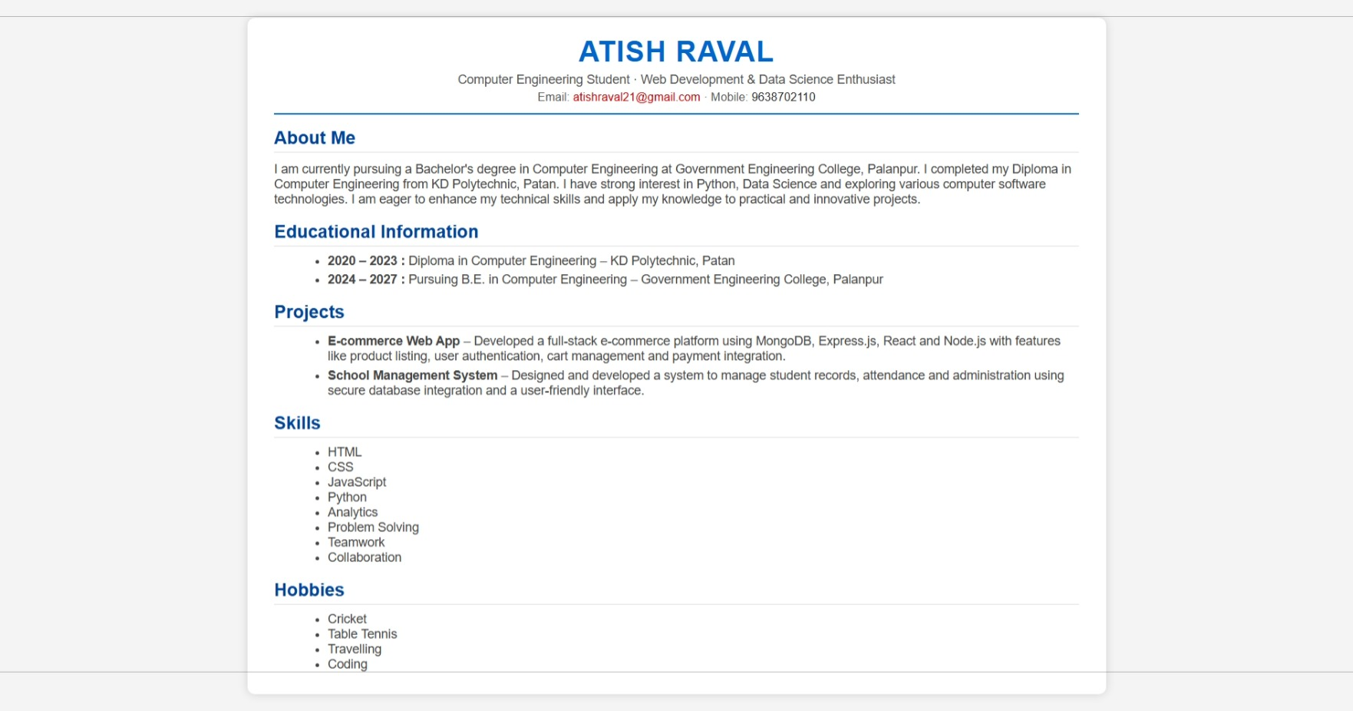

Conclusion:

Quiz:

- Explain Internal CSS VS Inline CSS.

- CSS stands for .

- Which HTML tag is used to define an internal style sheet?

Suggested Reference:

  - https://www.geeksforgeeks.org/types-of-css-cascading-style-sheet/

References used by the students:

Rubric wise marks obtained:

Rubrics | 1 | 2 | 3 | Total
Marks

Experiment No: 9
Use External, Internal, Inline CSS to format College Web site that you created in Practical No.03
Date:

Competency and PracticalSkills:

Relevant CO: 1 Objectives:
- To understand use of External CSS
Theory:

External CSS

  - An external file is a good idea when you have a number of pages, or even a complete site, which you need to control in terms of presentation.
  - it saves lots of effort as at one time you would have needed to alter each page individually.
  - With an external style sheet, you can change the look of an entire website by changing just one file!
  - Each HTML page must include a reference to the external style sheet file inside the <link> element, inside the head section.
  - External CSS file must be saved with a .css extension.
  - Example

HTML Code : index.html
<!DOCTYPE html>
<html>
<head>
<link rel="stylesheet" type="text/css" href="mystyle.css">
</head>
<body>
<h1>This is a heading</h1>
<p>This is a paragraph.</p>
</body>
</html>
CSS Code : mystyle.css

body {
background-color: lightblue;
}
h1 {
color: navy; margin-left: 20px;
}
Implementation:
Use External, Internal, Inline CSS to format Information Technology Department Web Pages that you created in Practical No. 03.

<!DOCTYPE html>
<html>
<head>
<title>GEC Palanpur</title>

<style>

body{
margin:0;
font-family:Arial;
background:linear-gradient(135deg,#dbeafe,#eef2ff,#f0f9ff);
}

/* Header */
.header{
background:linear-gradient(135deg,#001f4d,#0052cc,#0080ff);
color:white;
text-align:center;
padding:30px;
}

/* Navbar */
.nav{
background:white;
text-align:center;
padding:12px;
}

.nav a{
text-decoration:none;
color:#003366;
font-weight:bold;
margin:0 10px;
}

/* Content */
.content{
max-width:900px;
margin:30px auto;
background:white;
padding:25px;
border-radius:12px;
box-shadow:0 10px 30px rgba(0,0,0,0.15);
}

.content h2{
color:#003366;
}

.footer{
background:#003366;
color:white;
text-align:center;
padding:15px;
margin-top:30px;
}

</style>

</head>

<body>

<div class="header">
<h1>Government Engineering College, Palanpur</h1>
<p>Computer Engineering Department</p>
</div>

<div class="nav">
<a href="#home">Home</a>
<a href="#departments">Departments</a>
<a href="#courses">Courses</a>
<a href="#library">Library</a>
</div>

<div class="content" id="home">

<h2>Welcome to GEC Palanpur</h2>
<p>
Government Engineering College Palanpur provides quality engineering education
with modern labs and experienced faculty.
</p>

<h2 id="departments">Departments</h2>
<ul>
<li>Civil Engineering</li>
<li>Computer Engineering</li>
<li>Mechanical Engineering</li>
<li>Electrical Engineering</li>
</ul>

<h2 id="courses">Courses</h2>
<ul>
<li>B.E Civil Engineering</li>
<li>B.E Computer Engineering</li>
<li>B.E Mechanical Engineering</li>
<li>B.E Electrical Engineering</li>
</ul>

<h2 id="library">Library</h2>
<p>
The college library provides textbooks, journals and digital learning resources.
</p>

<p style="background:#fff3cd; padding:10px; border-left:5px solid orange;">
This paragraph shows <b>Inline CSS</b>.
</p>

</div>

<div class="footer">
© 2026 GEC Palanpur
</div>

</body>
</html>

Output:
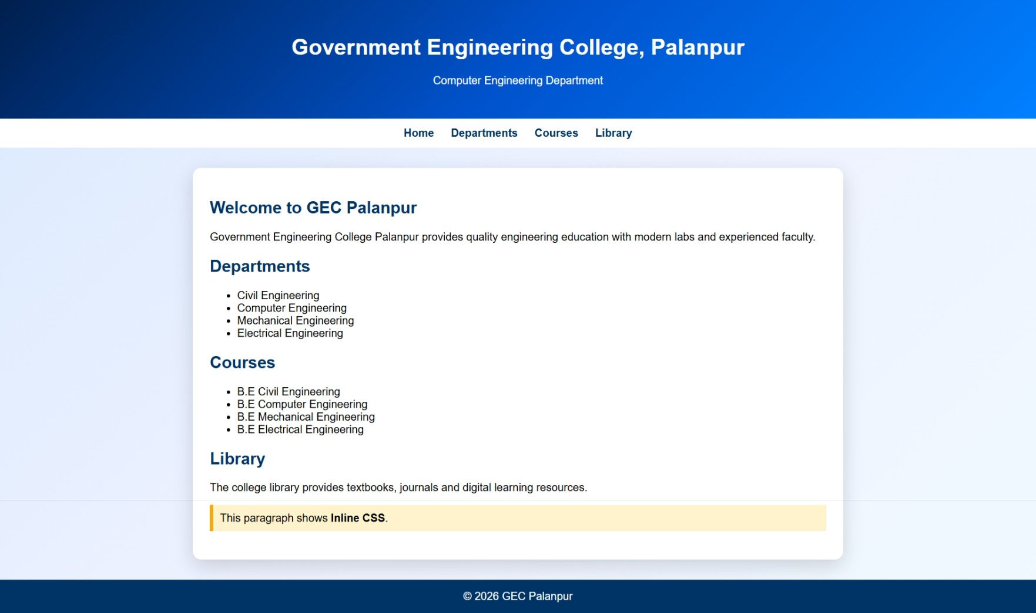

Conclusion:

Quiz:

- Explain External CSS.

- Compare Internal, Inline and External CSS.

- Which property is used to change the background color?

- Which property is used to change the text color of the element?

Suggested Reference:

  - https://www.geeksforgeeks.org/types-of-css-cascading-style-sheet/

References used by the students:

Rubric wise marks obtained:

Rubrics | 1 | 2 | 3 | Total
Marks

Experiment No: 10 Develop a java script to display today’s date.
Date:

Competency and PracticalSkills:

Relevant CO: 2

Objectives:

- To understand how to write simple java script
Theory:

Javascript

  - Javascript is a client side scripting language.
  - HTML and CSS for static rendering of a page
  - Scripting languages allows content to change dynamically
  - Possible to interact with the user beyond what is possible with HTML
  - Scripts are programs and can execute on the client side (the one with the browser) or server.
  - Running a script on the client saves processing time on the server
  - Types Of Javascript
    - Internal Javascript
      - JavaScript code is placed in the head and body section of an HTML page.
      - Example

<html>
<head>
<title>Internal JavaScript</title>
<script type="text/javascript"> document.write("Hello World.!!!");
</script>
</head>
<body>
</body>
</html>
    - External JavaScript
      - If you want to use the same script on several pages it could be good idea to place the code in separate file, rather than writing it on each.
      - JavaScript code are stored in separate external file using the .js extension (Ex: external.js).
      - Example:

HTML File : index.html
<html>
<head>
<title>External JavaScript</title>
<script type="text/javascript" src="external.js"></script>
</head>
<body>
</body>
</html>
External JavaScript file : external.js
document.write("This is External Javascript Example.!!!");
Implementation:
Develop a java script to display today’s date.

<!DOCTYPE html>
<html>
<head>
<title>Experiment 10: Today's Date</title>
</head>

<body>

<h2>Current Date Display</h2>

<p id="dateDisplay" style="font-size:18px; color:blue;"></p>

<script type="text/javascript">

var today = new Date();

// Extract day, month, year
var day = today.getDate();
var month = today.getMonth() + 1;
var year = today.getFullYear();

// Format output
var formattedDate = day + "/" + month + "/" + year;

document.getElementById("dateDisplay").innerHTML =
"Today's Date is: " + formattedDate;

</script>

</body>
</html>

Output:


Conclusion:

Quiz:

- What is javascript?

- Explain internal and external javascript.

Suggested Reference:

  - https://www.w3schools.com/JSREF/jsref_obj_date.asp
References used by the students: Rubric wise marks obtained:
Rubrics | 1 | 2 | 3 | Total
Marks

Experiment No: 11
Develop simple calculator for addition, subtraction, multiplication and division operation using java script.
Date:

Competency and PracticalSkills:

Relevant CO: 2 Objectives:
- To understand the use of mathematical operators in javascript.
- To understand the use of document object model.
- To understand javascript event handling.
Theory:

Javascript Syntax

How to create and use variables?
varx,y,z; x=5;
y=5 z=x+y;
document.write(“total is : ”+z)
The HTML DOM (Document Object Model)

- When a web page is loaded, the browser creates a Document Object Model of the page.
- The HTML DOM model is constructed as a tree of Objects:
- Using DOM Javascript can
  - change all the HTML elements in the page
  - change all the HTML attributes in the page
  - change all the CSS styles in the page
  - remove existing HTML elements and attributes
  - add new HTML elements and attributes
  - react to all existing HTML events in the page
  - create new HTML events in the page

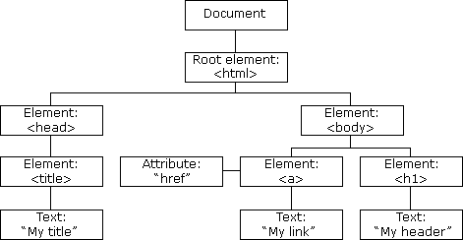

Figure 1 Document Object Model
DOM Examples
Example 1: following example changes the content of <p> element
<html>
<body>
<p id="demo"></p>
<script>
document.getElementById("demo").innerHTML = "Hello World!";
</script>

</body>
</html>
Here getElementById is a method, while innerHTML is a property.

Example 2: Validate Numeric Input

<!DOCTYPE html>
<html>
<body>
<h2>Number Validation</h2>

<p>Enter a number between 1 and 10:</p>
<input id="numb">

<button type="button" onclick="myFunction()">Submit</button>
<p id="demo"></p>

<script>
function myFunction() {
// Get the value of the input field with id="numb" let x = document.getElementById("numb").value;
// If x is Not a Number or less than one or greater than 10 let text;
if (isNaN(x) || x < 1 || x > 10) { text = "Input not valid";
} else {
text = "Input OK";
}
document.getElementById("demo").innerHTML = text;
}
</script>
</body>
</html>
Implementation:
Develop simple calculator for addition, subtraction, multiplication and division operation using java script.

<!DOCTYPE html>
<html>
<head>
<title>Experiment 11: Simple Calculator</title>

<style>
body {
font-family: Arial, sans-serif;
text-align: center;
margin-top: 50px;
background-color: #f4f6f9;
}

.calculator-box {
width: 320px;
margin: auto;
padding: 20px;
border-radius: 12px;
background-color: white;
box-shadow: 0 10px 25px rgba(0,0,0,0.2);
}

input {
width: 90%;
padding: 10px;
margin-bottom: 10px;
border-radius: 6px;
border: 1px solid #ccc;
}

button {
width: 45%;
padding: 10px;
margin: 5px;
cursor: pointer;
background-color: #007bff;
color: white;
border: none;
border-radius: 6px;
}

button:hover {
background-color: #0056b3;
}

#result {
margin-top: 20px;
padding: 12px;
background-color: #e9f5ff;
border-left: 5px solid #007bff;
font-weight: bold;
font-size: 18px;
color: #003366;
border-radius: 6px;
}
</style>
</head>

<body>

<div class="calculator-box">

<h2>Simple Calculator</h2>

<input type="number" id="num1" placeholder="Enter first number">
<input type="number" id="num2" placeholder="Enter second number">

<br>

<button onclick="calc('add')">Add (+)</button>
<button onclick="calc('sub')">Sub (-)</button>
<button onclick="calc('mul')">Mul (*)</button>
<button onclick="calc('div')">Div (/)</button>

<p id="result">Result will appear here</p>

</div>

<script>

function calc(operation){

var n1 = parseFloat(document.getElementById("num1").value);
var n2 = parseFloat(document.getElementById("num2").value);
var ans;
var symbol;

if(isNaN(n1) || isNaN(n2)){
document.getElementById("result").innerHTML = "⚠ Please enter valid numbers";
return;
}

if(operation == "add"){
ans = n1 + n2;
symbol = "+";
}
else if(operation == "sub"){
ans = n1 - n2;
symbol = "-";
}
else if(operation == "mul"){
ans = n1 * n2;
symbol = "*";
}
else if(operation == "div"){
if(n2 == 0){
document.getElementById("result").innerHTML = "⚠ Cannot divide by zero";
return;
}
ans = n1 / n2;
symbol = "/";
}

document.getElementById("result").innerHTML =
"Result: " + n1 + " " + symbol + " " + n2 + " = " + ans;

}

</script>

</body>
</html>

Output:
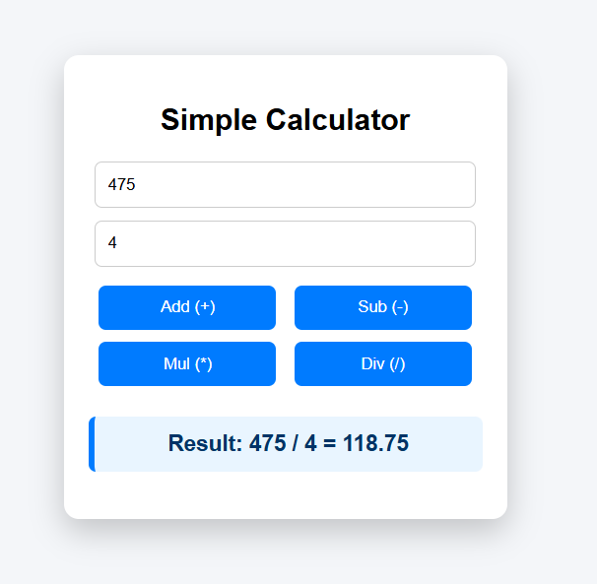

Conclusion:
Quiz:

1. Explain Document Object Model.

Suggested Reference:

- https://www.w3schools.com/js/js_htmldom.asp
- https://www.w3schools.com/js/js_validation.asp
References used by the students:

Rubric wise marks obtained:

Rubrics | 1 | 2 | 3 | Total
Marks

Experiment No: 12
Write a java script code to combine and display the information in textbox when the button is clicked use registration page that you created in Practical No.4.
Date:

Competency and PracticalSkills:

Relevant CO: 2

Objectives:

- To understand the use of DOM for getting values from Form Controls.
- To understand event handling with javascript
Theory:

What is an Event?

- JavaScript's interaction with HTML is handled through events that occur when the user or the browser manipulates a page.
- When the page loads, it is called an event. When the user clicks a button, that click too is an event. Other examples include events like pressing any key, closing a window, resizing a window, etc.
- Developers can use these events to execute JavaScript coded responses, which cause buttons to close windows, messages to be displayed to users, data to be validated, and virtually any other type of response imaginable.
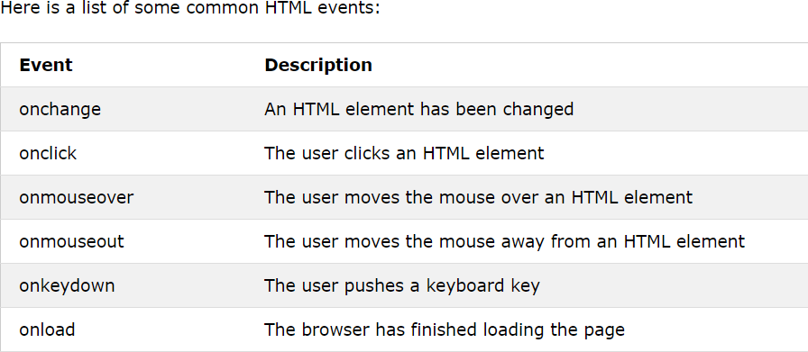
- Events are a part of the Document Object Model (DOM) Level 3 and every HTML element contains a set of events which can trigger JavaScript Code.

- ​
Example: the following javascript example demonstrate how to fetch value from textbox and
display using alert()

<!DOCTYPE html>
<html>
<head>
<title>Java Script Demo</title>
<script>
function showData()
{
var uname,email;
uname = document.forms["myform"]["username"].value; email = document.forms["myform"]["email"].value; alert("you entered name:"+uname+" email:"+email);
}
</script>
</head>
<body>
<form name="myform">
UserName : <input type="text" name="username"/><br/> Password : <input type="email" name="email"/><br/>
<input type="button" value="display" onclick="showData()" />
</form>
</body>
</html>
Implementation:
Write a java script code to combine and display the information in textbox when the button is clicked use registration page that you created in Practical No.4.

<!DOCTYPE html>
<html lang="en">
<head>
<meta charset="UTF-8">
<title>Experiment 12: Form Data Display</title>

<style>
body {
font-family: Arial;
background-color: #f4f4f4;
}

.container {
width: 600px;
margin: 30px auto;
background-color: #ffffff;
padding: 20px 30px;
border-radius: 8px;
box-shadow: 0 0 10px rgba(0,0,0,0.15);
}

h2 {
text-align: center;
color: #003366;
}

table { width: 100%; }

td { padding: 6px; }

input, select, textarea {
width: 95%;
padding: 5px;
border-radius: 4px;
border: 1px solid #ccc;
}

.buttons {
text-align: center;
}

input[type="button"] {
background: green;
color: white;
}

input[type="submit"] {
background: #003366;
color: white;
}

input[type="reset"] {
background: gray;
color: white;
}

#finalResult {
width: 95%;
background: #e9ecef;
margin-top: 10px;
}
</style>

</head>

<body>

<div class="container">
<h2>User Registration (Exp 12)</h2>

<form name="regForm">

<table>

<tr>
<td>Name:</td>
<td><input type="text" name="name" value="Atish Raval"></td>
</tr>

<tr>
<td>Date of Birth:</td>
<td><input type="date" name="dob" value="2004-05-18"></td>
</tr>

<tr>
<td>Gender:</td>
<td>
<input type="radio" name="gender" value="Male" checked> Male
<input type="radio" name="gender" value="Female"> Female
<input type="radio" name="gender" value="Other"> Other
</td>
</tr>

<tr>
<td>Email:</td>
<td><input type="email" name="email" value="240613107023@gecpalanpur.ac.in"></td>
</tr>

<tr>
<td>Mobile:</td>
<td><input type="text" name="mobile" value="9638702110"></td>
</tr>

<tr>
<td>Address:</td>
<td>
<textarea name="address">B-61 Om Housing Society, Vadodara, Gujarat</textarea>
</td>
</tr>

<tr>
<td>State:</td>
<td>
<select name="state">
<option selected>Gujarat</option>
<option>Rajasthan</option>
<option>Maharashtra</option>
<option>Delhi</option>
</select>
</td>
</tr>

<tr>
<td>Education:</td>
<td>
<select name="education">
<option>Diploma in Engineering</option>
<option selected>Bachelor of Engineering</option>
</select>
<br><br>
<label><input type="checkbox" checked> I agree to terms</label>
</td>
</tr>

<tr>
<td>Hobbies:</td>
<td>
<label><input type="checkbox" name="hobby" value="Cricket" checked> Cricket</label><br>
<label><input type="checkbox" name="hobby" value="Table Tennis" checked> Table Tennis</label><br>
<label><input type="checkbox" name="hobby" value="Travelling" checked> Travelling</label><br>
<label><input type="checkbox" name="hobby" value="Coding" checked> Coding</label>
</td>
</tr>

<tr>
<td colspan="2" class="buttons">
<input type="submit" value="Register">
<input type="button" value="Display Info" onclick="showData()">
<input type="reset" value="Clear">
</td>
</tr>

<tr>
<td colspan="2">
<textarea id="finalResult" rows="8" readonly></textarea>
</td>
</tr>

</table>

</form>

</div>

<script>

function showData(){

var form = document.forms["regForm"];

/* Gender */
var gender = "";
var g = document.getElementsByName("gender");
for(var i=0;i<g.length;i++){
if(g[i].checked){
gender = g[i].value;
break;
}
}

/* Hobbies */
var hobbies = [];
var h = document.getElementsByName("hobby");
for(var i=0;i<h.length;i++){
if(h[i].checked){
hobbies.push(h[i].value);
}
}

/* Result */
var result =
"Name: " + form["name"].value + "\n" +
"DOB: " + form["dob"].value + "\n" +
"Gender: " + gender + "\n" +
"Email: " + form["email"].value + "\n" +
"Mobile: " + form["mobile"].value + "\n" +
"Address: " + form["address"].value + "\n" +
"State: " + form["state"].value + "\n" +
"Education: " + form["education"].value + "\n" +
"Hobbies: " + hobbies.join(", ");

document.getElementById("finalResult").value = result;

}

</script>

</body>
</html>

Output:
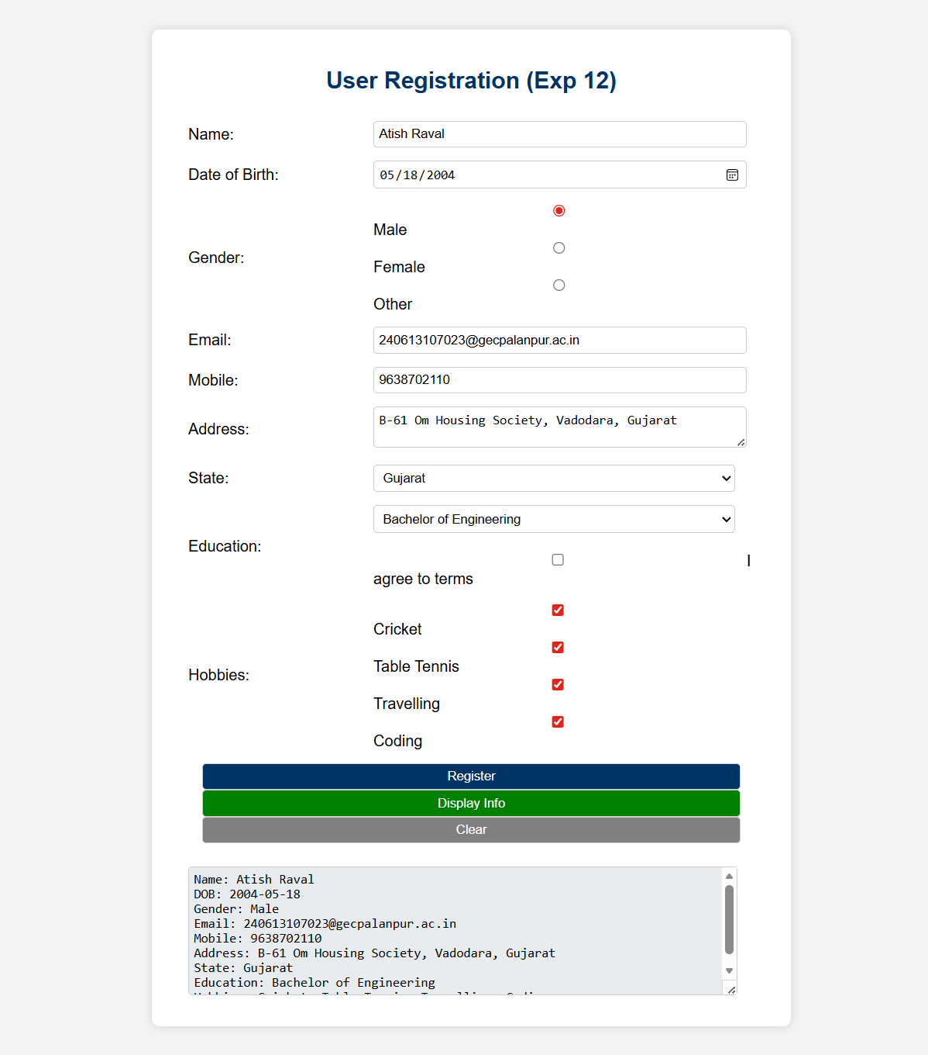

Conclusion:

Quiz:

- Explain event handling with javascript.

Suggested Reference:

  - https://www.w3schools.com/js/js_validation.asp
References used by the students:

Rubric wise marks obtained:

Rubrics | 1 | 2 | 3 | Total
Marks

Experiment No: 13
Use JavaScript to implement validation in Practical No.4.
Date:

Competency and PracticalSkills:

Relevant CO: 2

Objectives:

1. To understand validation using javascript.
Theory:

Javascript can be used for HTML form validation
Following example demonstrate form validation using javascript

<!DOCTYPE html>
<html>
<head>
<script>
function validateForm() {
let x = document.forms["myForm"]["fname"].value; if (x == "") {
alert("Name must be filled out"); return false;
}
}
</script>
</head>
<body>
<h2>JavaScript Validation</h2>
<form name="myForm" action="/action_page.php" onsubmit="return validateForm()" method="post">
Name: <input type="text" name="fname">
<input type="submit" value="Submit">
</form>

</body>
</html>

Implementation:

Use JavaScript to Implement validation in Practical No.4.

<!DOCTYPE html>
<html lang="en">
<head>
<meta charset="UTF-8">
<title>Experiment 13: Form Validation</title>

<style>
body {
font-family: Arial;
background-color: #f4f4f4;
}

.container {
width: 600px;
margin: 30px auto;
background-color: white;
padding: 20px 30px;
border-radius: 8px;
box-shadow: 0 0 10px rgba(0,0,0,0.15);
}

h2 {
text-align: center;
color: #003366;
}

table { width: 100%; }
td { padding: 6px; }

input, select, textarea {
width: 95%;
padding: 5px;
}

.buttons {
text-align: center;
}

input[type="submit"] {
background: #003366;
color: white;
padding: 8px 20px;
}

input[type="reset"] {
background: gray;
color: white;
padding: 8px 20px;
}
</style>

</head>

<body>

<div class="container">
<h2>User Registration (With Validation)</h2>

<form name="regForm" onsubmit="return validateForm()">

<table>

<tr>
<td>Name:</td>
<td><input type="text" name="name" value="Atish Raval"></td>
</tr>

<tr>
<td>DOB:</td>
<td><input type="date" name="dob" value="2004-05-18"></td>
</tr>

<tr>
<td>Gender:</td>
<td>
<input type="radio" name="gender" value="Male" checked> Male
<input type="radio" name="gender" value="Female"> Female
</td>
</tr>

<tr>
<td>Email:</td>
<td><input type="email" name="email" value="240613107023@gecpalanpur.ac.in"></td>
</tr>

<tr>
<td>Mobile:</td>
<td><input type="text" name="mobile" value="9638702110"></td>
</tr>

<tr>
<td>Address:</td>
<td>
<textarea name="address">Vadodara, Gujarat</textarea>
</td>
</tr>

<tr>
<td>State:</td>
<td>
<select name="state">
<option value="">--Select--</option>
<option selected>Gujarat</option>
<option>Rajasthan</option>
<option>Maharashtra</option>
</select>
</td>
</tr>

<tr>
<td>Education:</td>
<td>
<select name="education">
<option value="">--Select--</option>
<option>Diploma in Engineering</option>
<option selected>Bachelor of Engineering</option>
</select>
<br><br>
<label>
<input type="checkbox" name="terms" checked> I agree to terms
</label>
</td>
</tr>

<tr>
<td>Hobbies:</td>
<td>
<input type="checkbox" name="hobby" value="Cricket" checked> Cricket<br>
<input type="checkbox" name="hobby" value="Table Tennis" checked> Table Tennis<br>
<input type="checkbox" name="hobby" value="Travelling" checked> Travelling<br>
<input type="checkbox" name="hobby" value="Coding" checked> Coding
</td>
</tr>

<tr>
<td colspan="2" class="buttons">
<input type="submit" value="Register">
<input type="reset" value="Clear">
</td>
</tr>

</table>

</form>

</div>

<script>

function validateForm(){

var form = document.forms["regForm"];

/* Name */
if(form["name"].value == ""){
alert("Enter Name");
return false;
}

/* Gender */
var gender = false;
var g = document.getElementsByName("gender");

for(var i=0;i<g.length;i++){
if(g[i].checked){ gender = true; }
}

if(!gender){
alert("Select Gender");
return false;
}

/* Email */
var email = form["email"].value;
if(email.indexOf("@") == -1){
alert("Invalid Email");
return false;
}

/* Mobile */
var mobile = form["mobile"].value;
if(mobile.length != 10 || isNaN(mobile)){
alert("Enter valid 10 digit mobile number");
return false;
}

/* State */
if(form["state"].value == ""){
alert("Select State");
return false;
}

/* Terms */
if(!form["terms"].checked){
alert("Accept Terms");
return false;
}

alert("Registration Successful!");
return true;

}

</script>

</body>
</html>

Output:
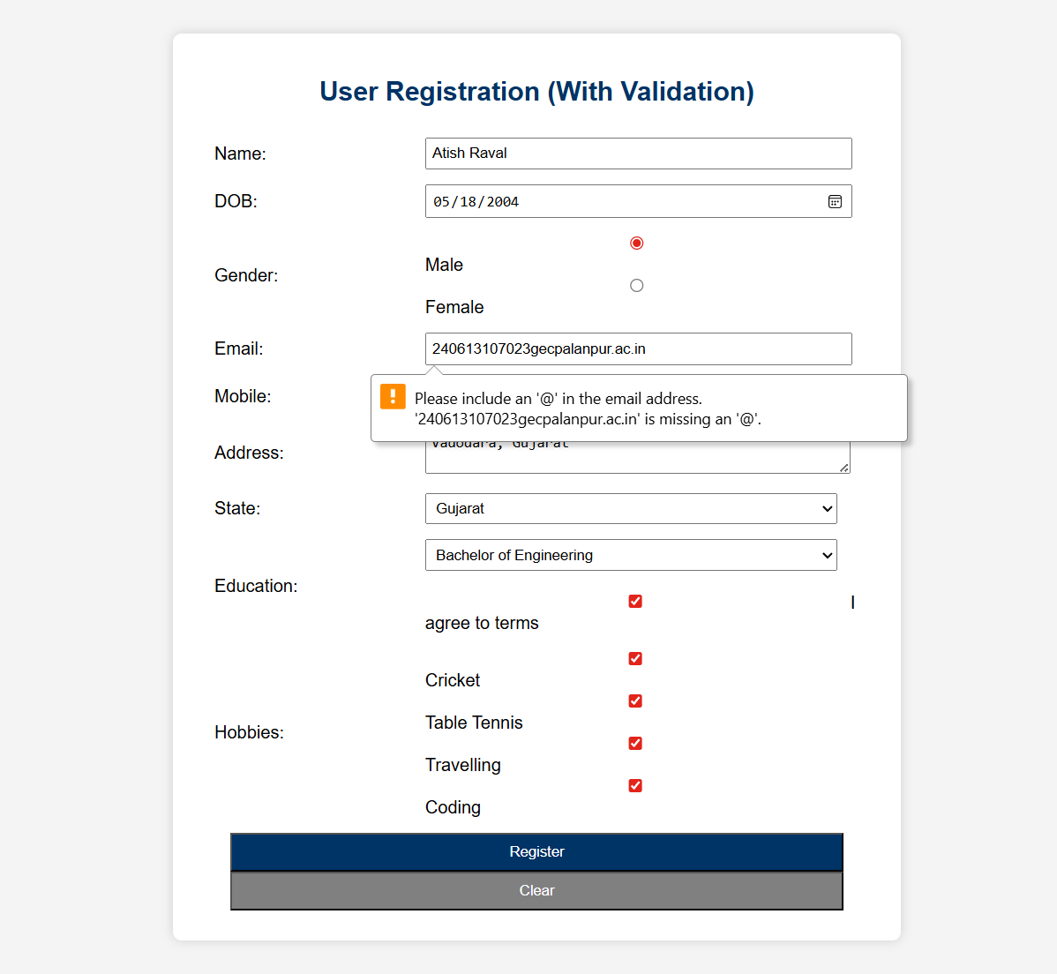

Conclusion:

Quiz:

- Explain javascript form validation.

Suggested Reference:

  - https://www.w3schools.com/js/js_validation.asp
References used by the students:

Rubric wise marks obtained:

Rubrics | 1 | 2 | 3 | Total
Marks

Experiment No: 14
Write a PHP program to check if number is prime or not.
Date:

Competency and PracticalSkills:

Relevant CO: 3 Objectives:
- To understand how to write simple php program
- To understand how to use php conditional and Loops Statement
Theory:

PHP

  - PHP is a server scripting language, and a powerful tool for making dynamic and interactive Web pages.
  - PHP is a widely-used, free, and efficient alternative to competitors such as Microsoft's ASP.
  - Syntax

<?php
// PHP code goes here
?>

  - Example:demonstrate printing Hello World

<!DOCTYPE html>
<html>
<body>

<?php
echo "Hello World";
?>
</body>
</html>

  - Creating (Declaring) PHP Variables

<?php
$txt = "Hello world!";
$x = 5;
$y = 10.5;
?>

  - PHP Conditional Statements

Statement | Syntax
PHP - The if Statement | if (condition) {  code to be executed if condition is true;  }
PHP - The if...else Statement | if (condition) {  code to be executed if condition is true;  } else {  code to be executed if condition is false;  }
PHP - The if...elseif...else Statement | if (condition) {  code to be executed if this condition is true;  } elseif (condition) {  code to be executed if first condition is false and this condition is true;  } else {  code to be executed if all conditions are false;  }

  - PHP Loop Statements

Statement | Syntax
The PHP while Loop | while (condition is true) {  code to be executed;  }

The PHP do...while Loop | do {  code to be executed;  } while (condition is true);
The PHP for Loop | for (init counter; test counter; increment counter)  {  code to be executed for each iteration;  }
The PHP foreach Loop | foreach ($array as $value)  {  code to be executed;  }

Implementation:

<!DOCTYPE html>
<html>
<head>
<title>Prime Number Checker</title>

<style>
body{
font-family: Arial;
text-align: center;
margin-top: 50px;
background: #f4f4f4;
}

.box{
width: 300px;
margin: auto;
padding: 20px;
background: white;
border-radius: 10px;
box-shadow: 0 0 10px rgba(0,0,0,0.2);
}

input{
padding: 8px;
margin: 5px;
}

button{
padding: 8px 15px;
background: #003366;
color: white;
border: none;
}

.result{
margin-top: 15px;
font-size: 18px;
font-weight: bold;
}
</style>

</head>

<body>

<div class="box">

<h2>Prime Number Checker</h2>

<form method="post">
Enter Number:<br>
<input type="number" name="num" required><br>
<button type="submit" name="check">Check</button>
</form>

<?php

if(isset($_POST['check'])){

$number = $_POST['num'];
$isPrime = true;

if($number <= 1){
$isPrime = false;
} else {
for($i=2; $i<=sqrt($number); $i++){
if($number % $i == 0){
$isPrime = false;
break;
}
}
}

if($isPrime){
echo "<div class='result' style='color:green;'>".$number." is a Prime Number</div>";
} else {
echo "<div class='result' style='color:red;'>".$number." is NOT a Prime Number</div>";
}
}

?>

</div>

</body>
</html>

Output:
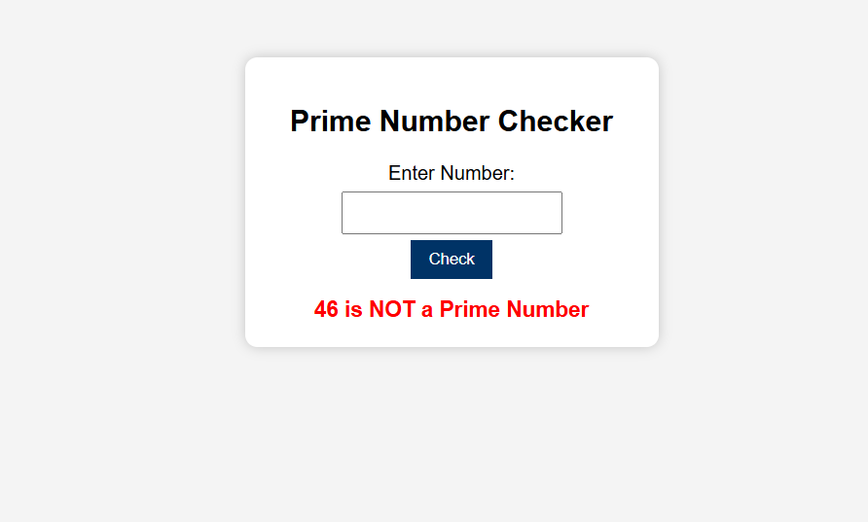

Conclusion:

Quiz:

- What is PHP? Explain PHP Syntax.

- Explain foreach Loop in PHP.

Suggested Reference:

  - https://www.w3schools.com/php/php_looping.asp

References used by the students:

Rubric wise marks obtained:

Rubrics | 1 | 2 | 3 | Total
Marks

